Ocean Uses and Marine Renewable Energy

Ben Best

2018-01-08 16:23

Table of Contents

## Ocean Use Layers

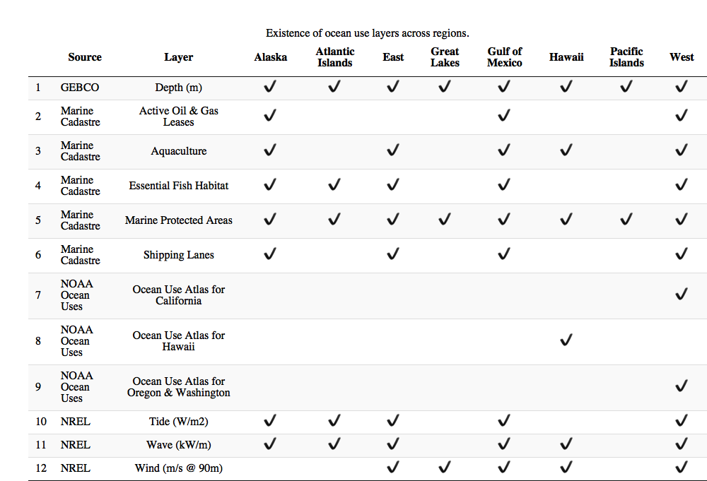

## Alaska

### Alaska: Map of Uses

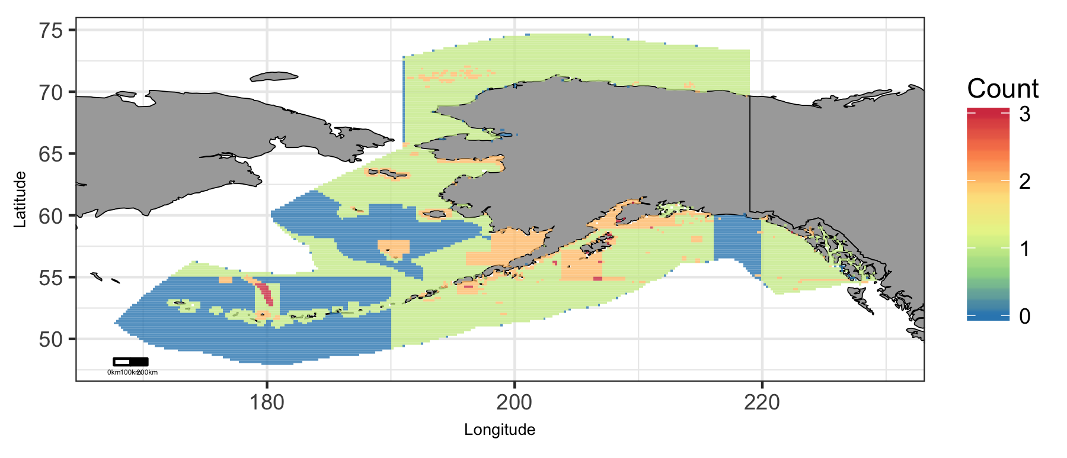

Map of cumulative ocean use in Alaska region.

### Alaska: Map of Depth

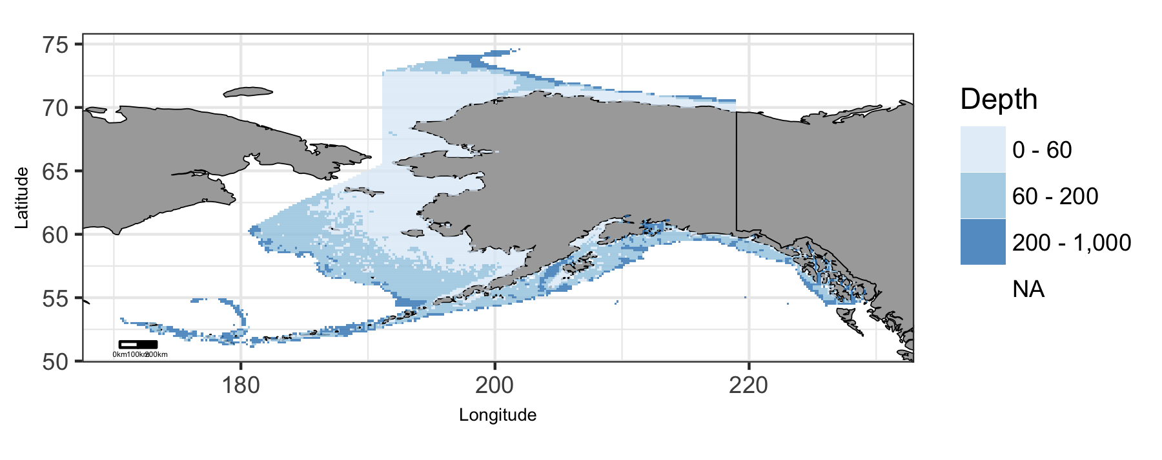

Map of viable depth in Alaska region.

### Alaska: Plot of Uses by Depth

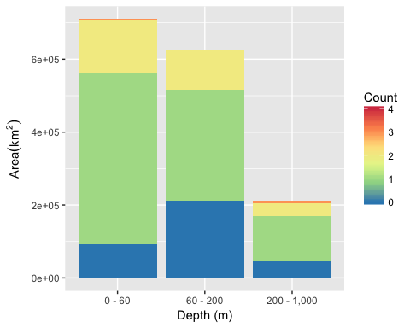

Area of Cumulative Ocean Use by Depth (m) for Alaska region. Cumulative use are counted and summarized by Depth (m) and area.

### Alaska: Table of Uses by Depth

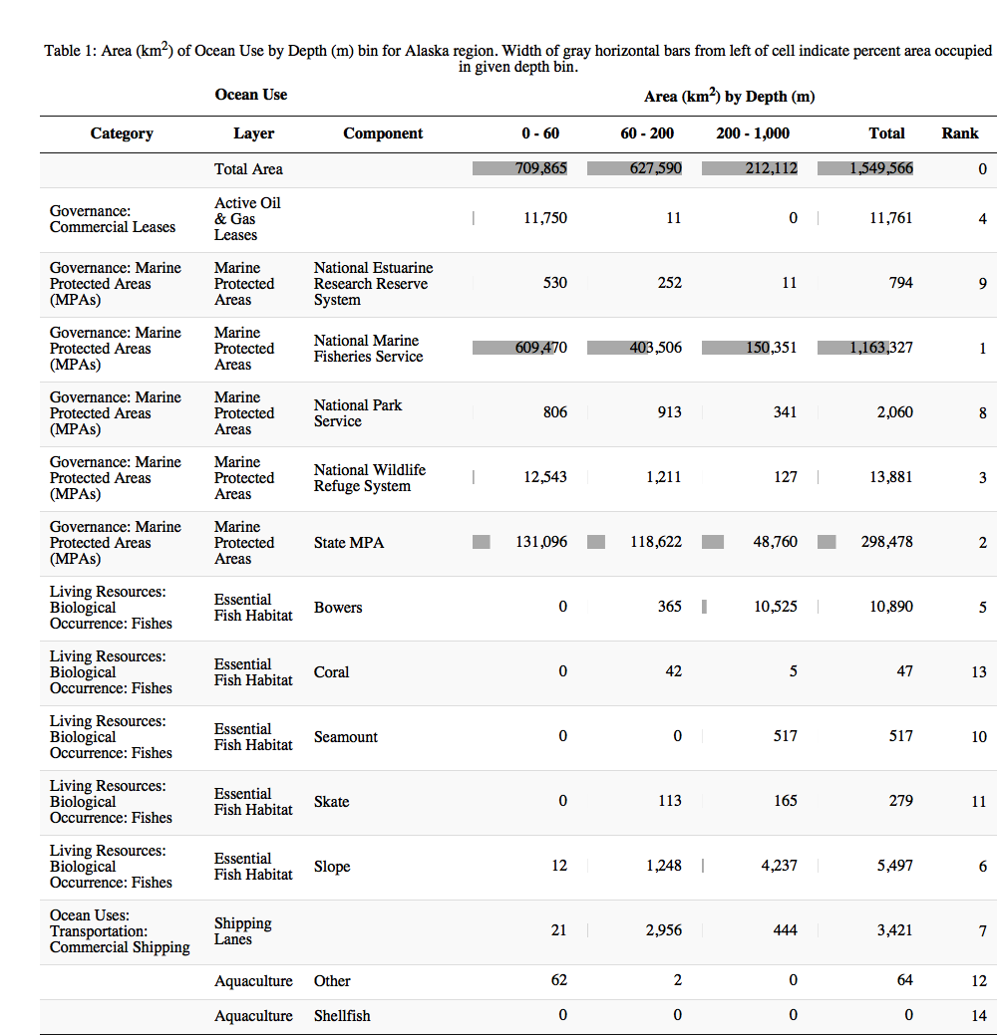

### Alaska: Map of Tide

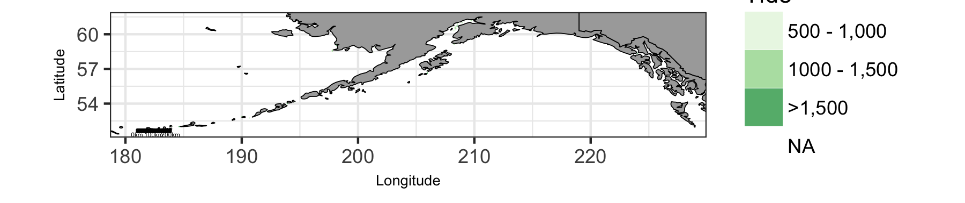

Map of viable tide in Alaska region.

### Alaska: Plot of Uses by Tide

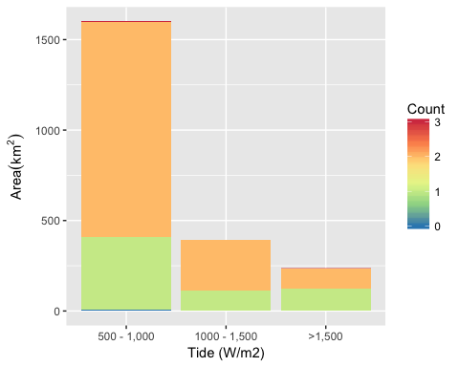

Area of Cumulative Ocean Use by Tide (W/m2) for Alaska region. Cumulative use are counted and summarized by Tide (W/m2) and area.

### Alaska: Table of Uses by Tide

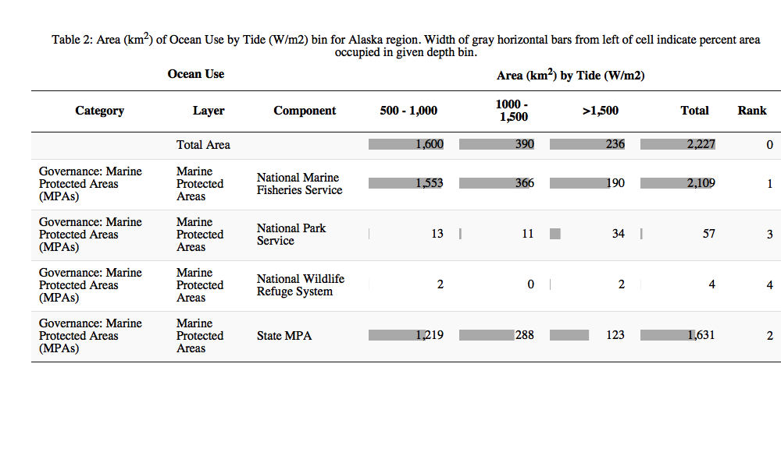

### Alaska: Map of Wave

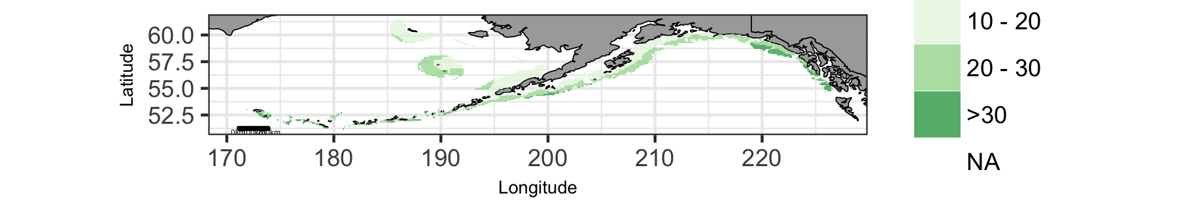

Map of viable wave in Alaska region.

### Alaska: Plot of Uses by Wave

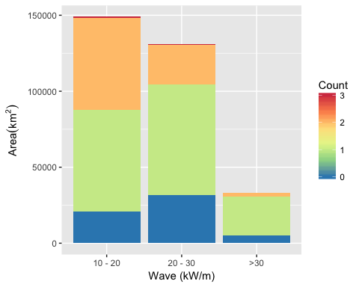

Area of Cumulative Ocean Use by Wave (kW/m) for Alaska region. Cumulative use are counted and summarized by Wave (kW/m) and area.

### Alaska: Table of Uses by Wave

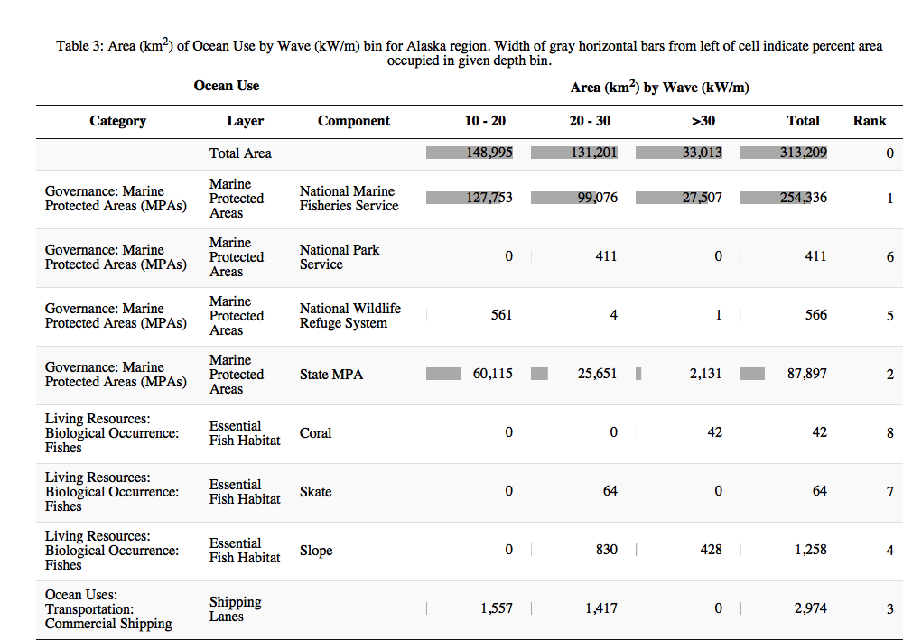

## Atlantic Islands

### Atlantic Islands: Map of Uses

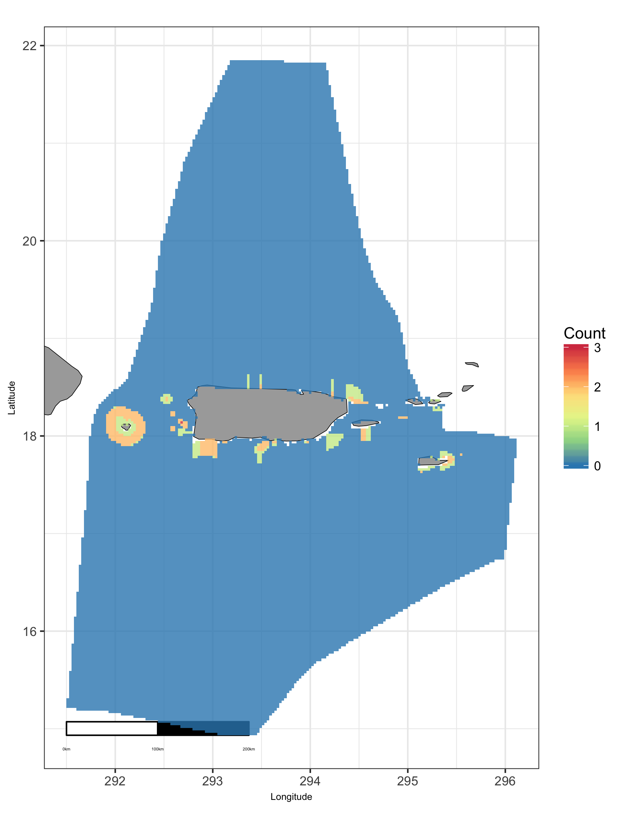

Map of cumulative ocean use in Atlantic Islands region.

### Atlantic Islands: Map of Depth

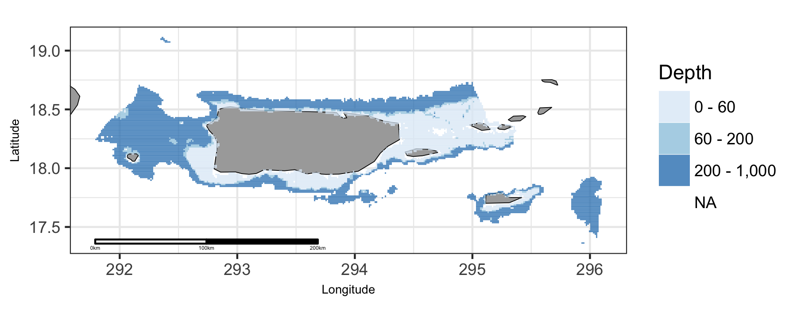

Map of viable depth in Atlantic Islands region.

### Atlantic Islands: Plot of Uses by Depth

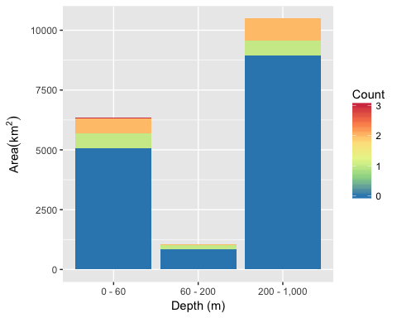

Area of Cumulative Ocean Use by Depth (m) for Atlantic Islands region. Cumulative use are counted and summarized by Depth (m) and area.

### Atlantic Islands: Table of Uses by Depth

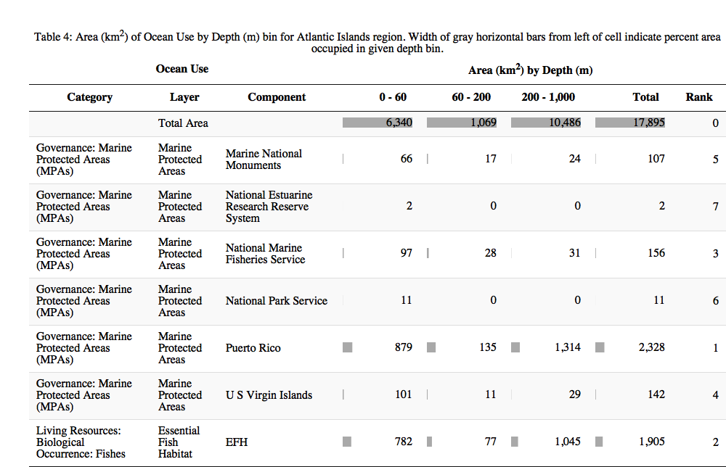

### Atlantic Islands: Map of Wave

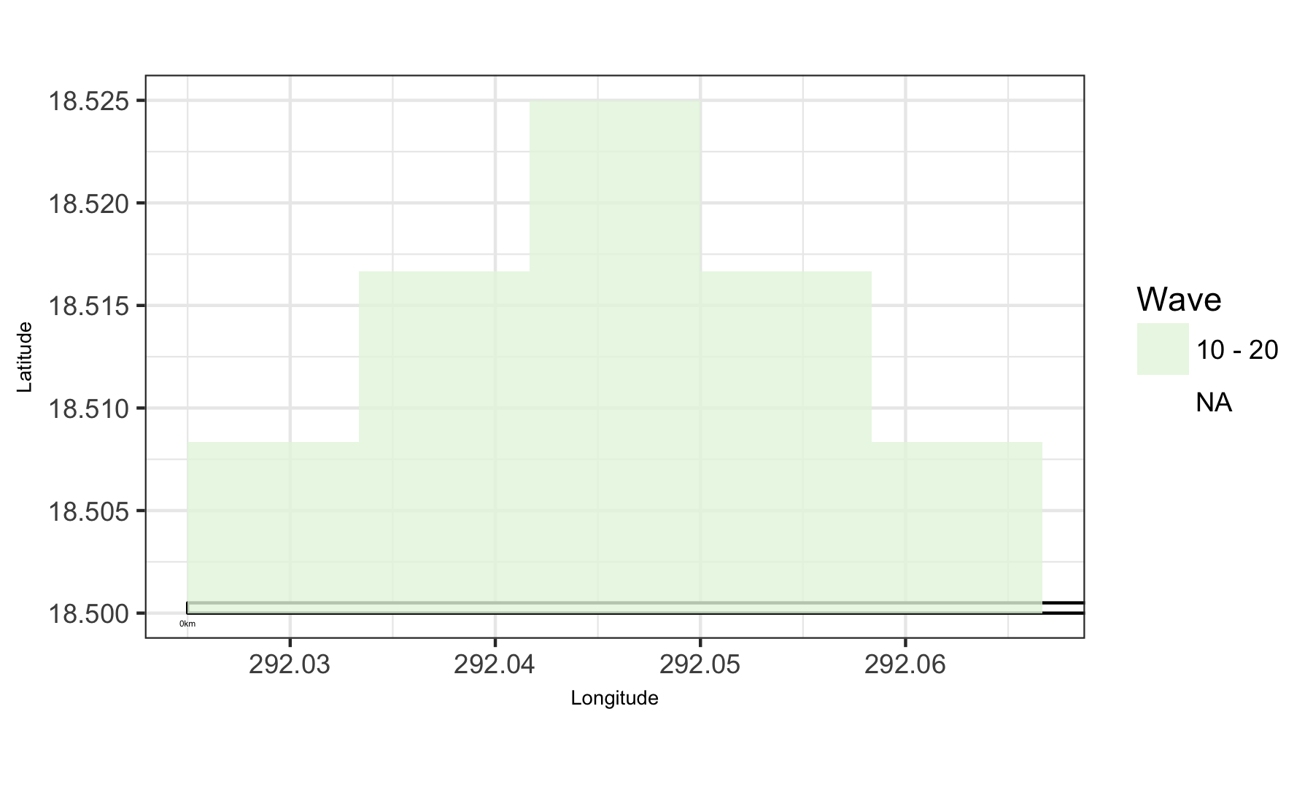

Map of viable wave in Atlantic Islands region.

### Atlantic Islands: Plot of Uses by Wave

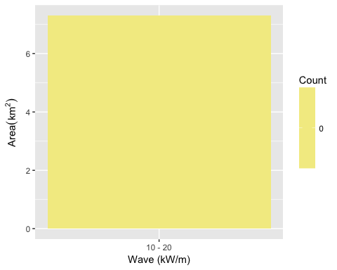

Area of Cumulative Ocean Use by Wave (kW/m) for Atlantic Islands region. Cumulative use are counted and summarized by Wave (kW/m) and area.

### Atlantic Islands: Table of Uses by Wave

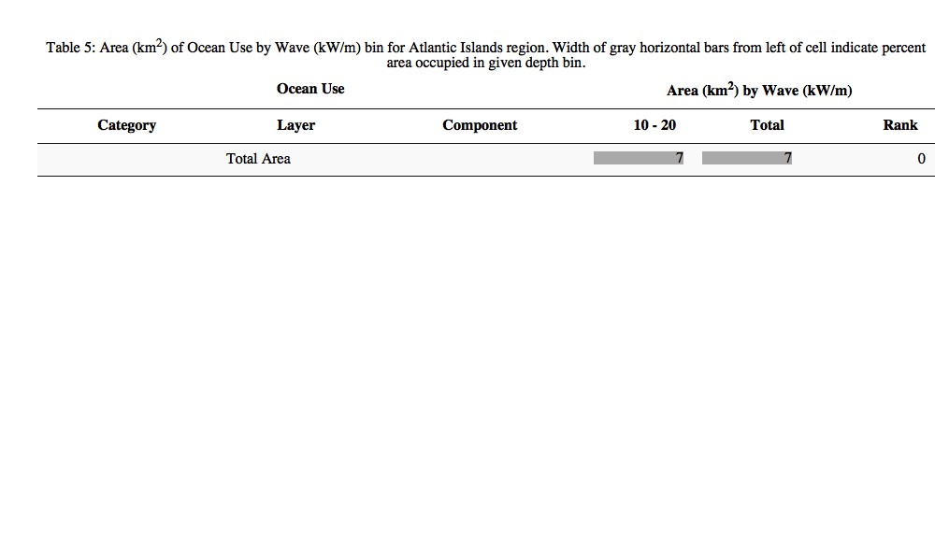

## East

### East: Map of Uses

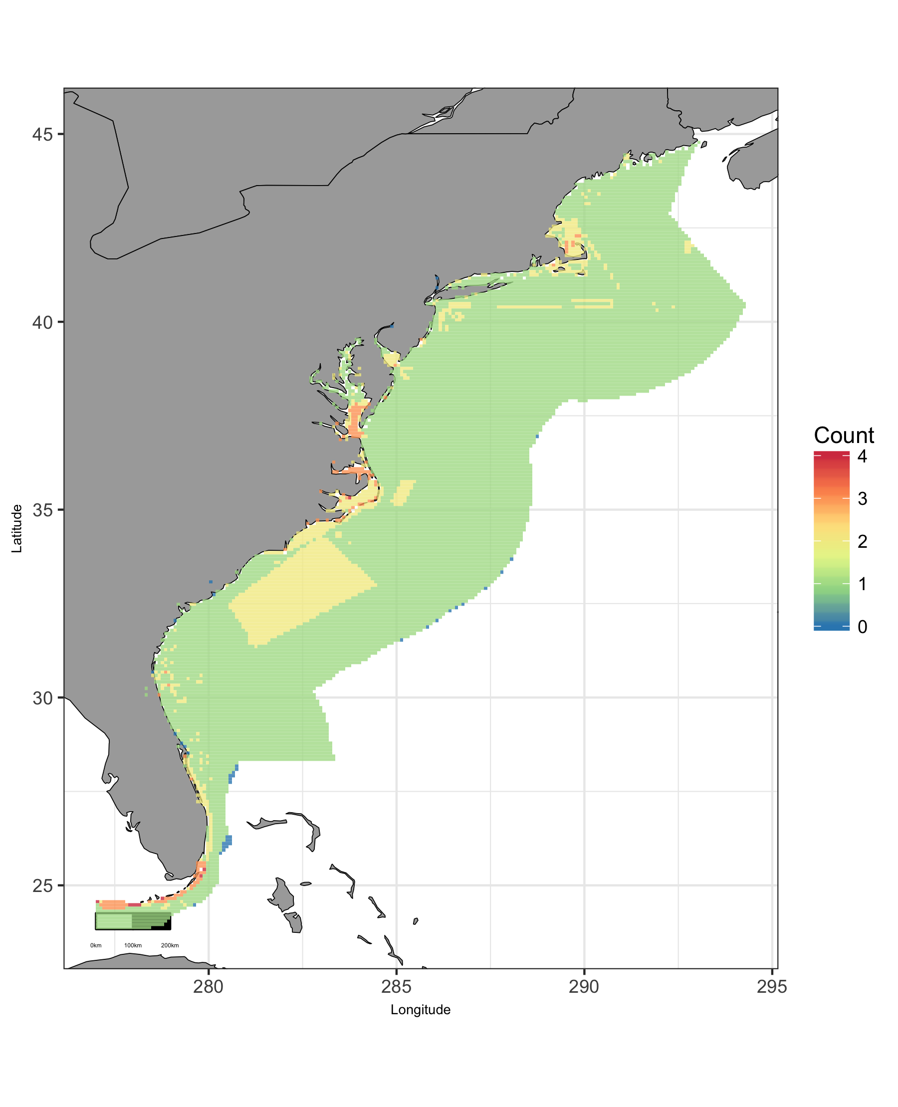

Map of cumulative ocean use in East region.

### East: Map of Depth

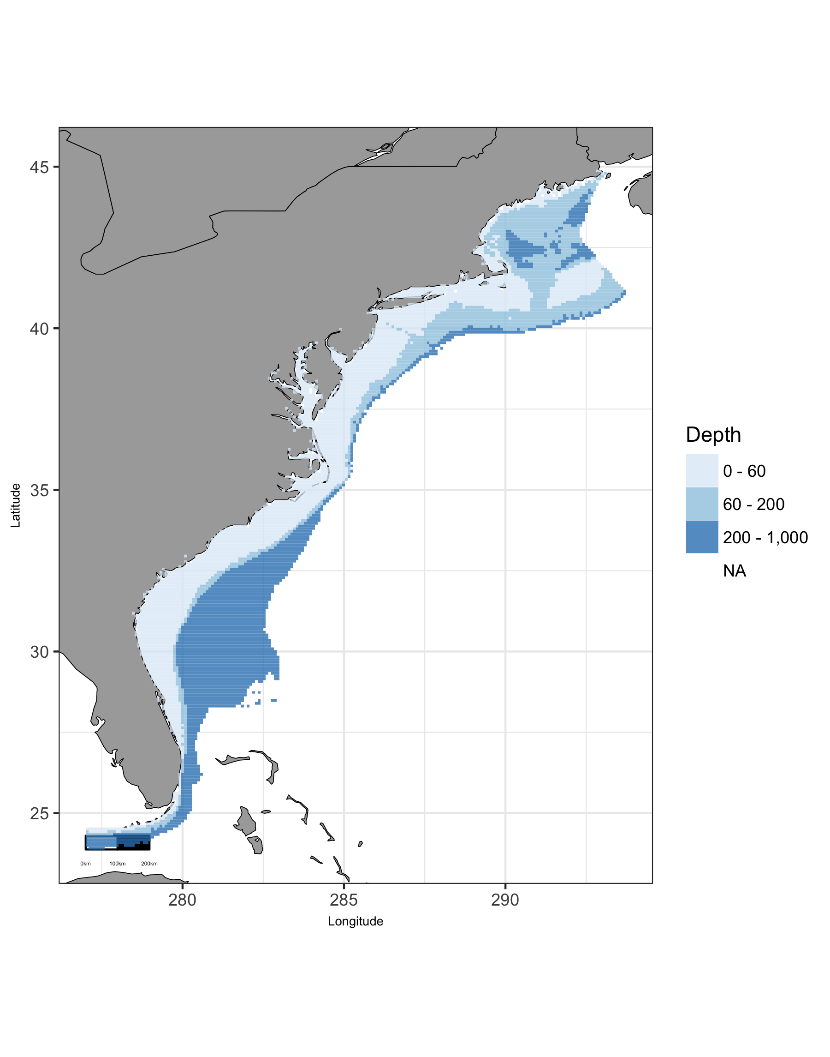

Map of viable depth in East region.

### East: Plot of Uses by Depth

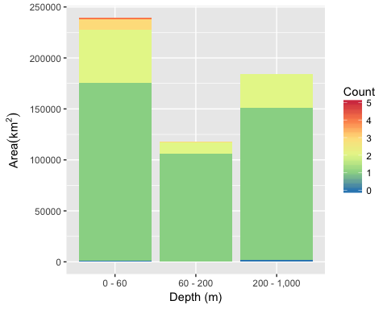

Area of Cumulative Ocean Use by Depth (m) for East region. Cumulative use are counted and summarized by Depth (m) and area.

### East: Table of Uses by Depth

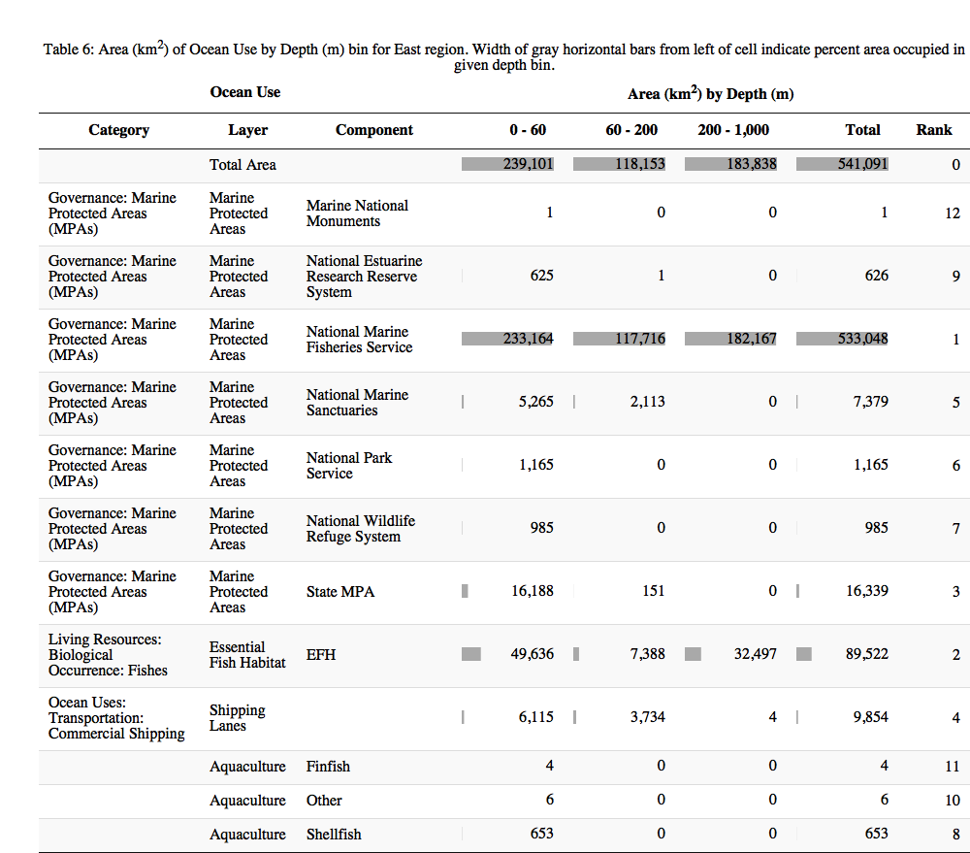

### East: Map of Tide

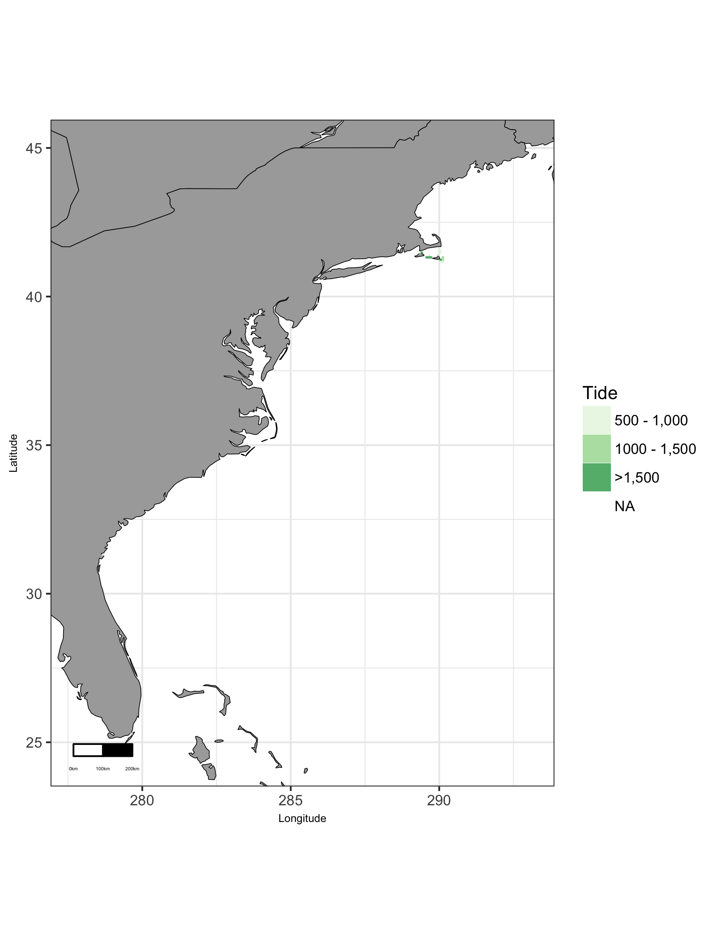

Map of viable tide in East region.

### East: Plot of Uses by Tide

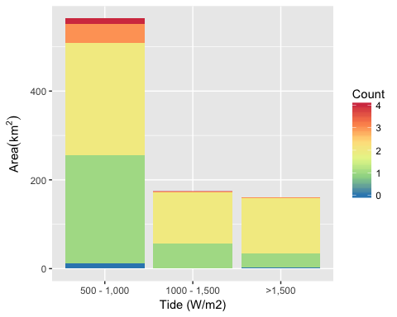

Area of Cumulative Ocean Use by Tide (W/m2) for East region. Cumulative use are counted and summarized by Tide (W/m2) and area.

### East: Table of Uses by Tide

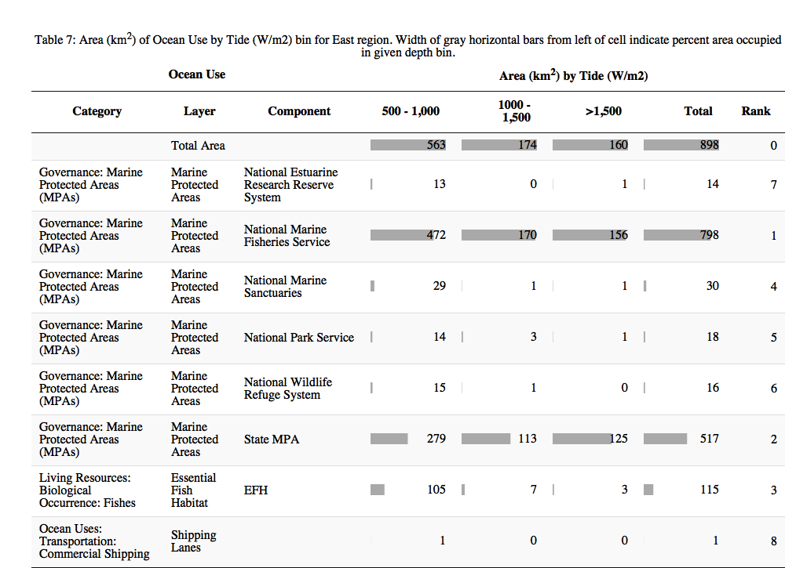

### East: Map of Wave

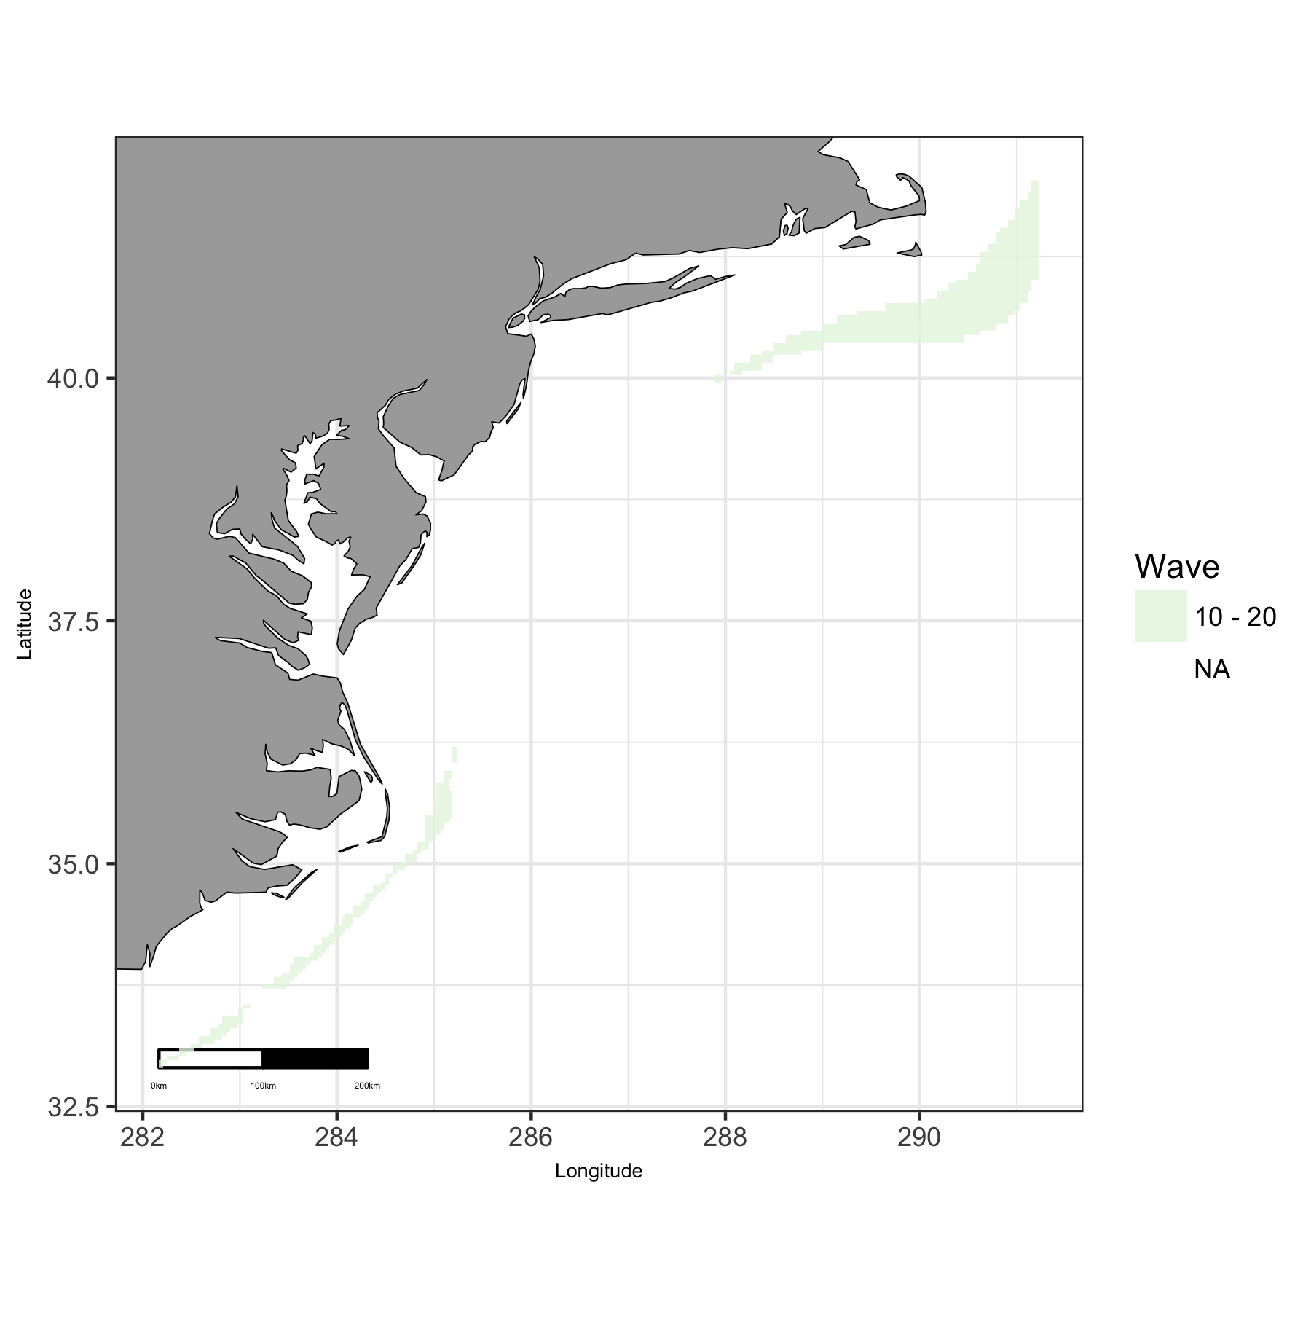

Map of viable wave in East region.

### East: Plot of Uses by Wave

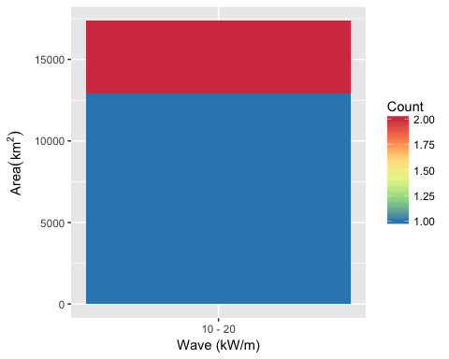

Area of Cumulative Ocean Use by Wave (kW/m) for East region. Cumulative use are counted and summarized by Wave (kW/m) and area.

### East: Table of Uses by Wave

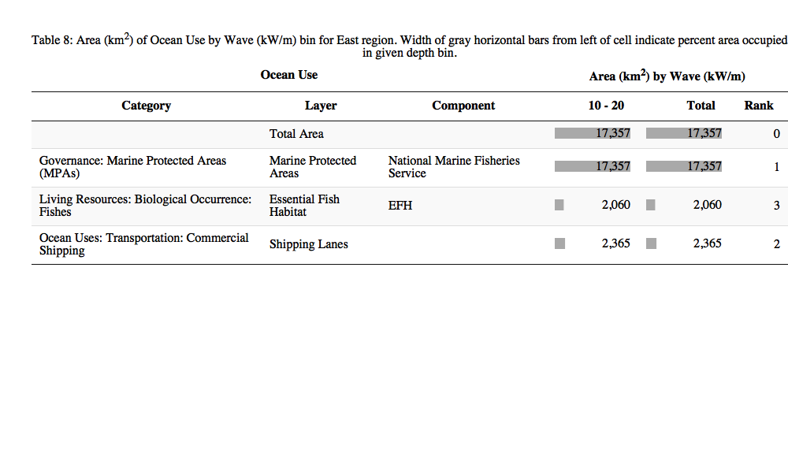

### East: Map of Wind

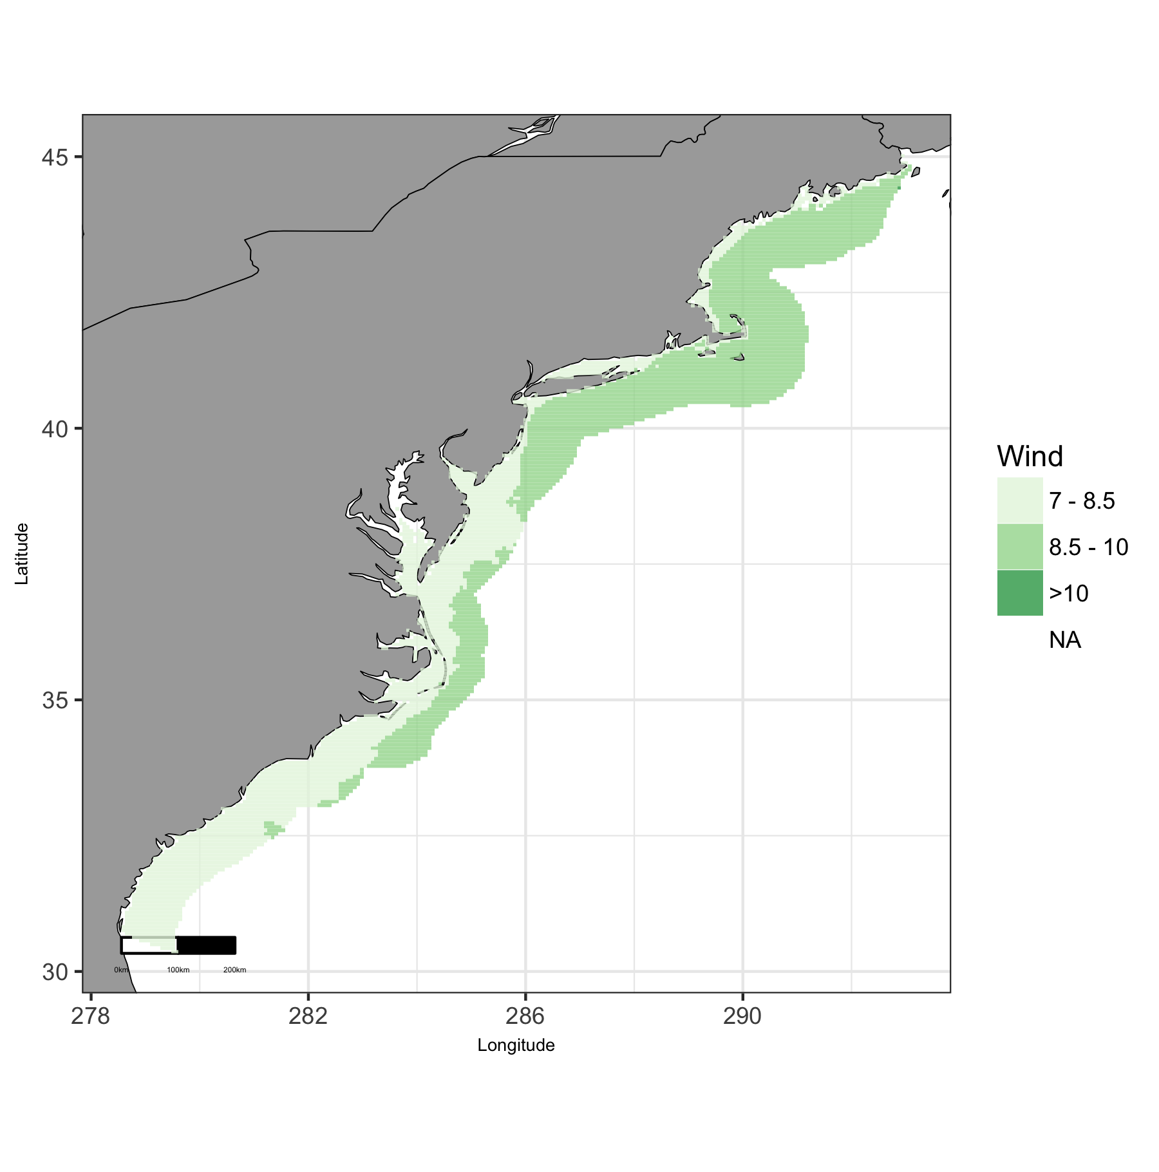

Map of viable wind in East region.

### East: Plot of Uses by Wind

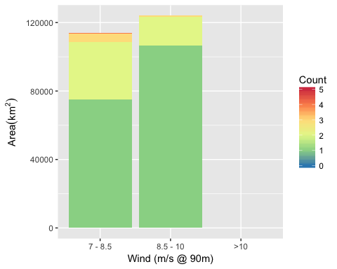

Area of Cumulative Ocean Use by Wind (m/s @ 90m) for East region. Cumulative use are counted and summarized by Wind (m/s @ 90m) and area.

### East: Table of Uses by Wind

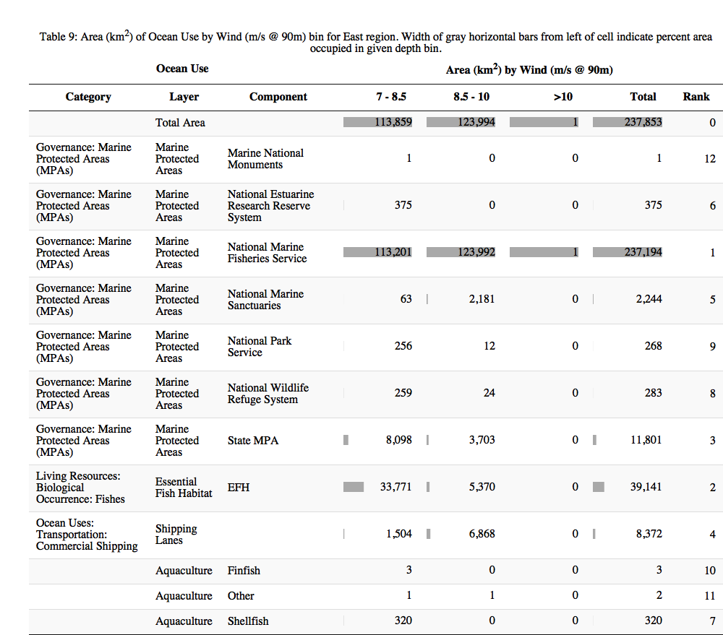

## Great Lakes

### Great Lakes: Map of Uses

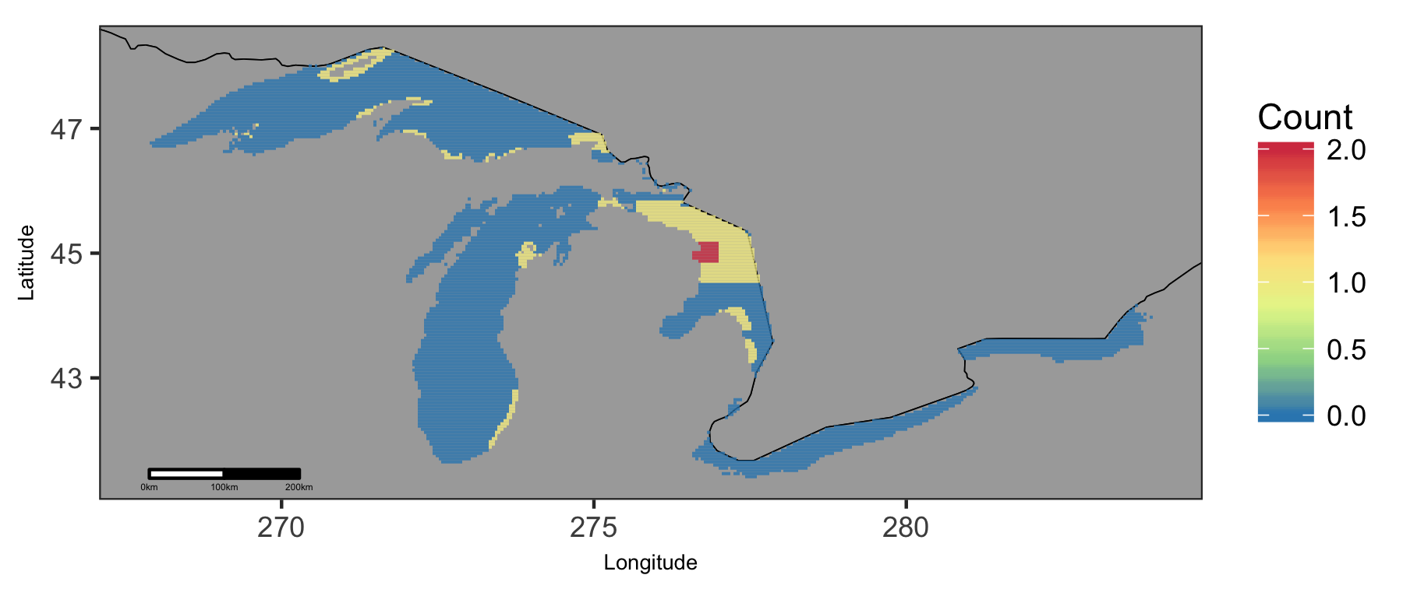

Map of cumulative ocean use in Great Lakes region.

### Great Lakes: Map of Depth

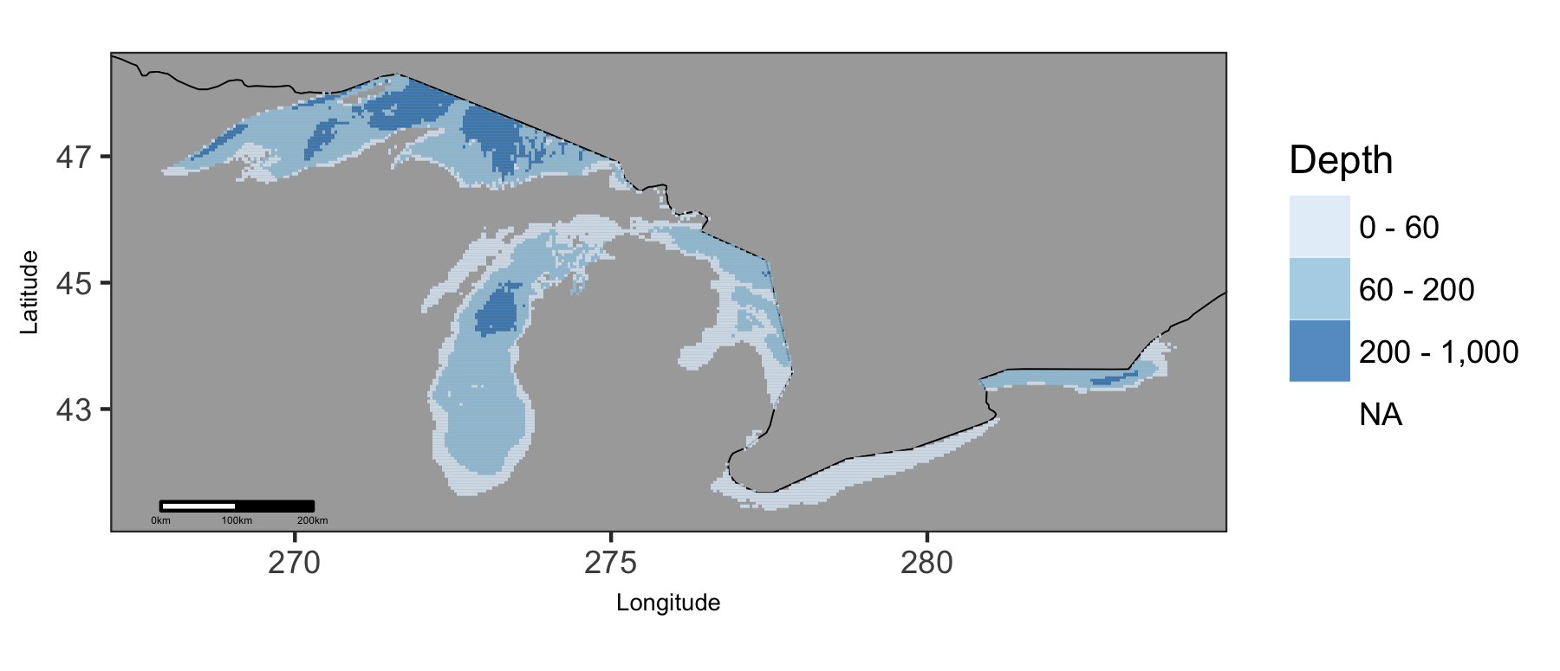

Map of viable depth in Great Lakes region.

### Great Lakes: Plot of Uses by Depth

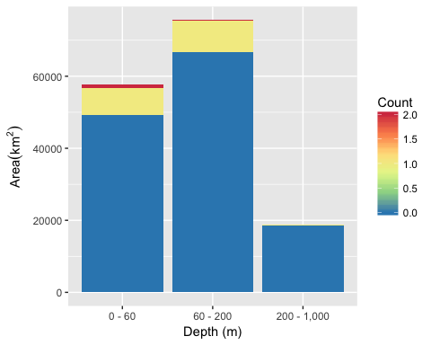

Area of Cumulative Ocean Use by Depth (m) for Great Lakes region. Cumulative use are counted and summarized by Depth (m) and area.

### Great Lakes: Table of Uses by Depth

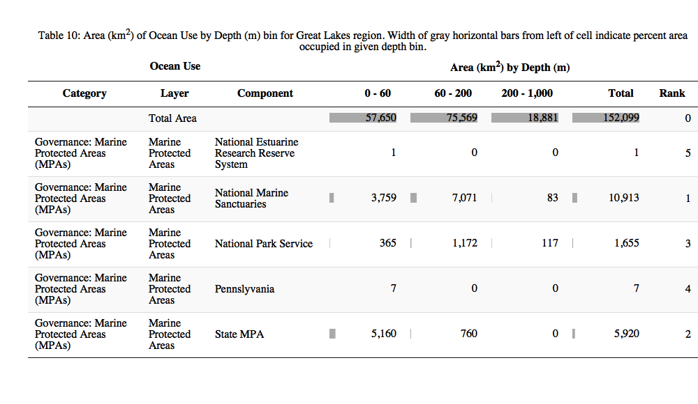

### Great Lakes: Map of Wind

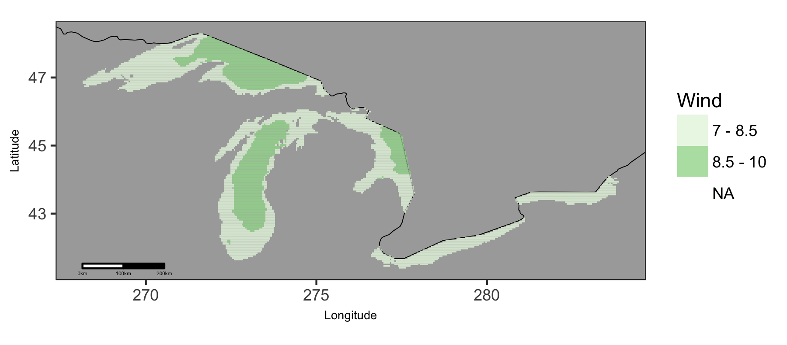

Map of viable wind in Great Lakes region.

### Great Lakes: Plot of Uses by Wind

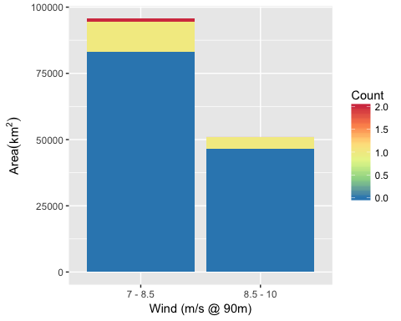

Area of Cumulative Ocean Use by Wind (m/s @ 90m) for Great Lakes region. Cumulative use are counted and summarized by Wind (m/s @ 90m) and area.

### Great Lakes: Table of Uses by Wind

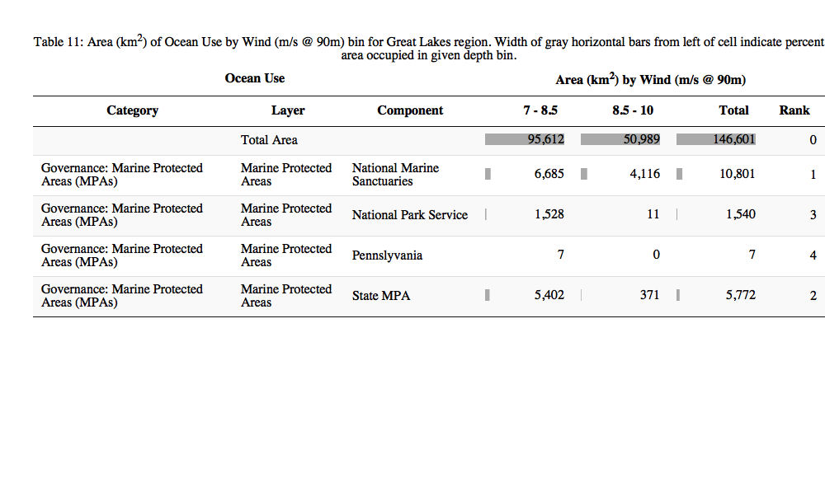

## Gulf of Mexico

### Gulf of Mexico: Map of Uses

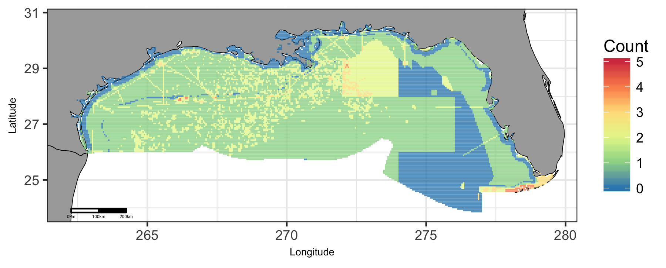

Map of cumulative ocean use in Gulf of Mexico region.

### Gulf of Mexico: Map of Depth

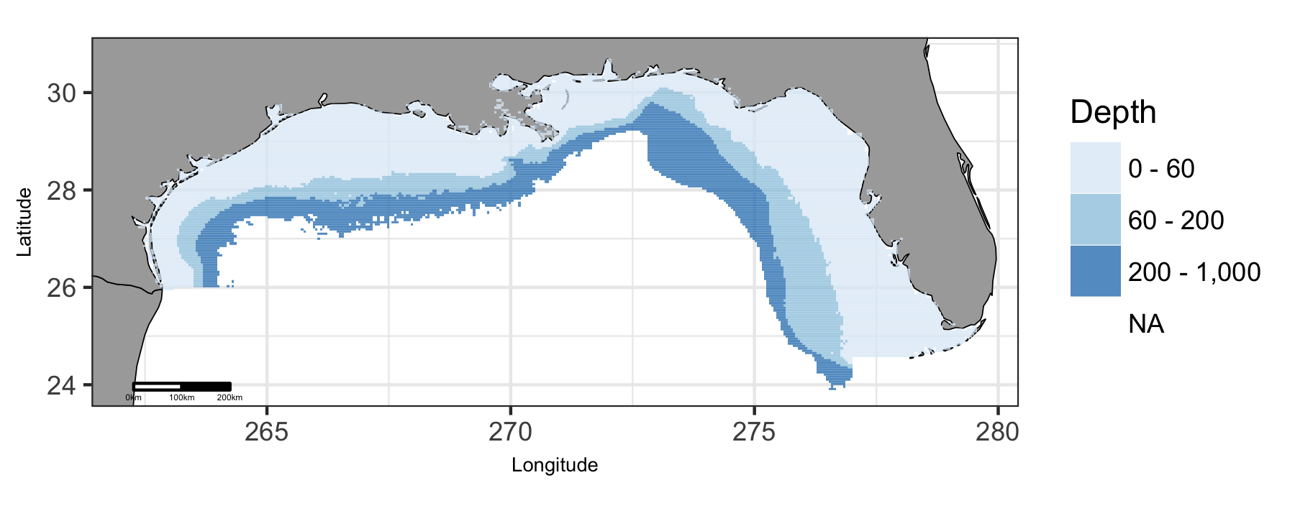

Map of viable depth in Gulf of Mexico region.

### Gulf of Mexico: Plot of Uses by Depth

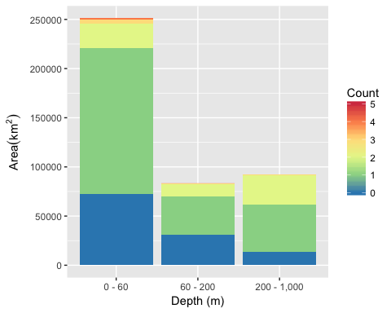

Area of Cumulative Ocean Use by Depth (m) for Gulf of Mexico region. Cumulative use are counted and summarized by Depth (m) and area.

### Gulf of Mexico: Table of Uses by Depth

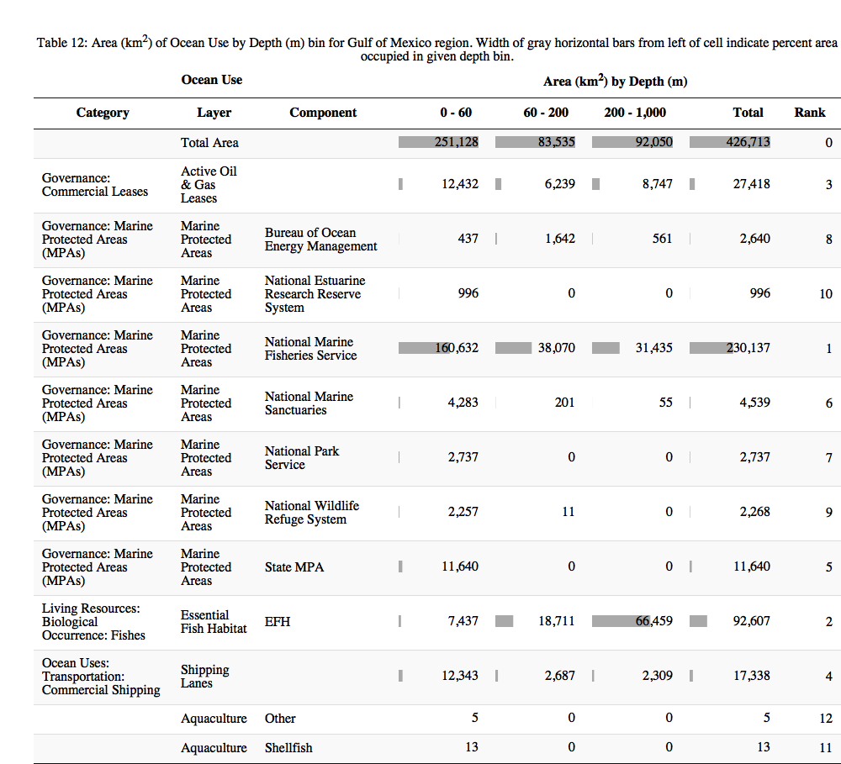

### Gulf of Mexico: Map of Tide

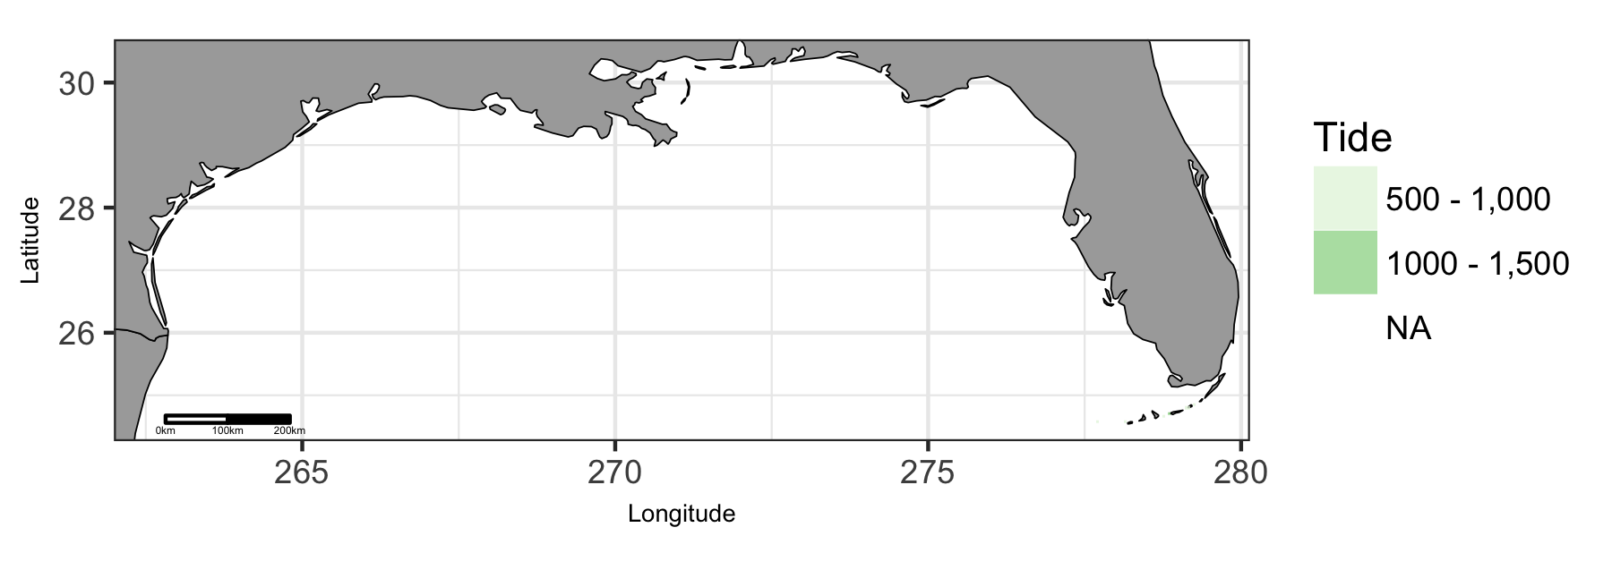

Map of viable tide in Gulf of Mexico region.

### Gulf of Mexico: Plot of Uses by Tide

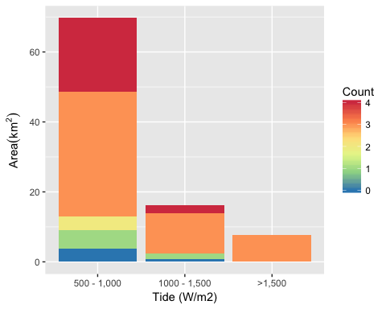

Area of Cumulative Ocean Use by Tide (W/m2) for Gulf of Mexico region. Cumulative use are counted and summarized by Tide (W/m2) and area.

### Gulf of Mexico: Table of Uses by Tide

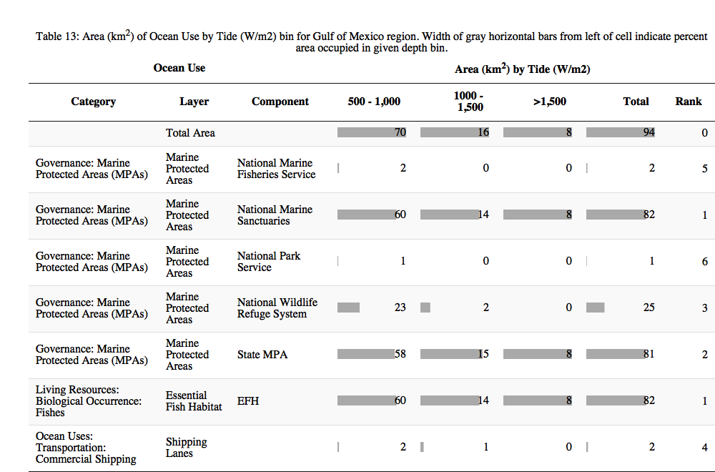

### Gulf of Mexico: Map of Wind

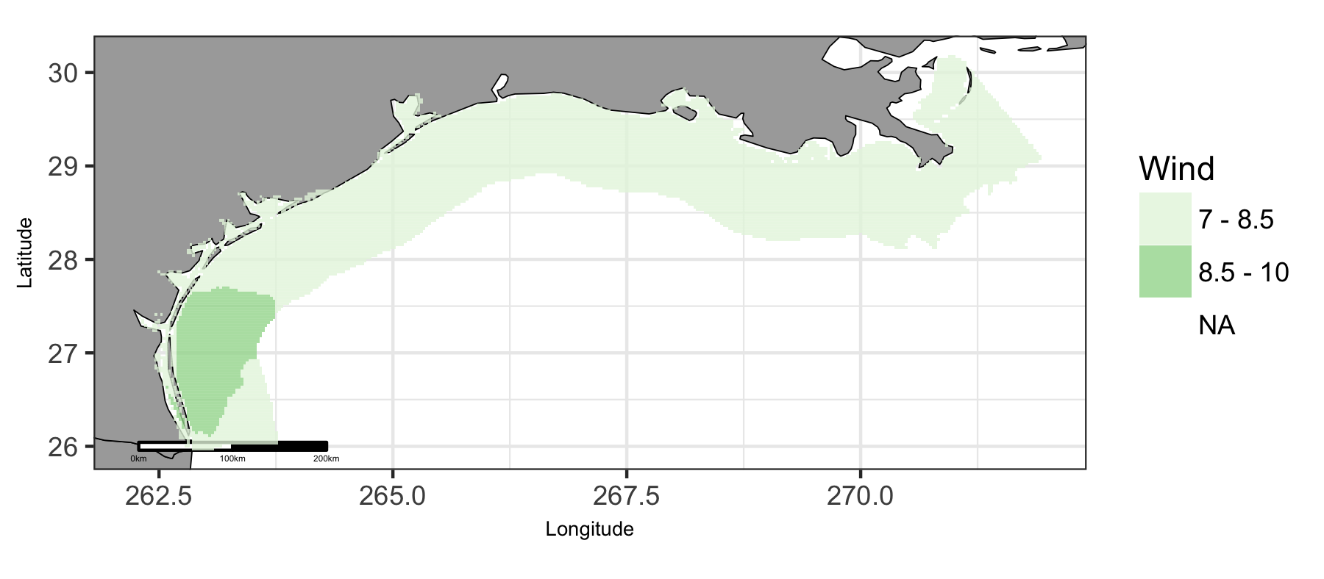

Map of viable wind in Gulf of Mexico region.

### Gulf of Mexico: Plot of Uses by Wind

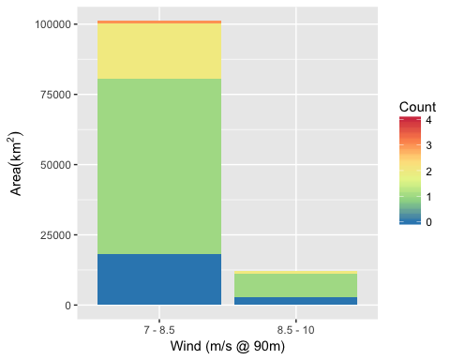

Area of Cumulative Ocean Use by Wind (m/s @ 90m) for Gulf of Mexico region. Cumulative use are counted and summarized by Wind (m/s @ 90m) and area.

### Gulf of Mexico: Table of Uses by Wind

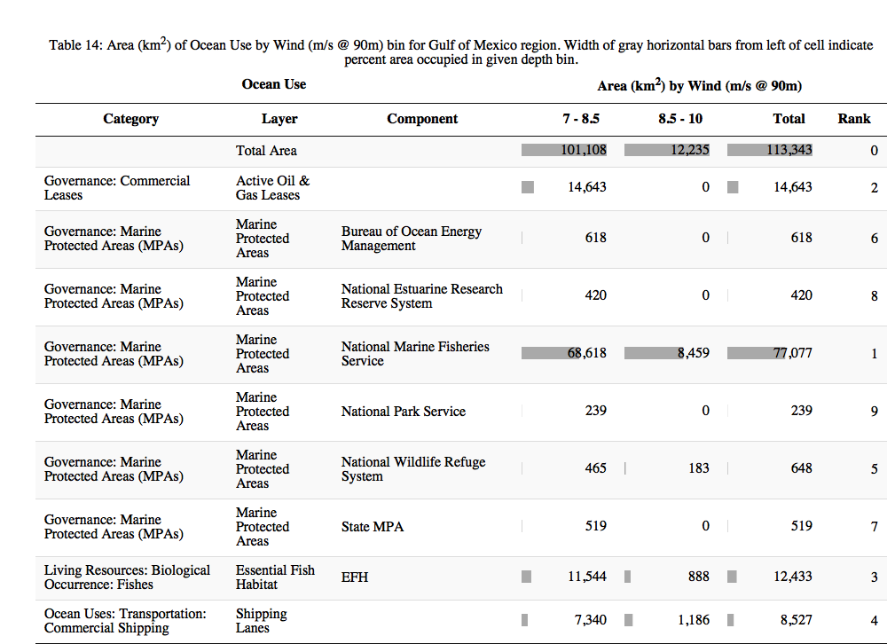

## Hawaii

### Hawaii: Map of Uses

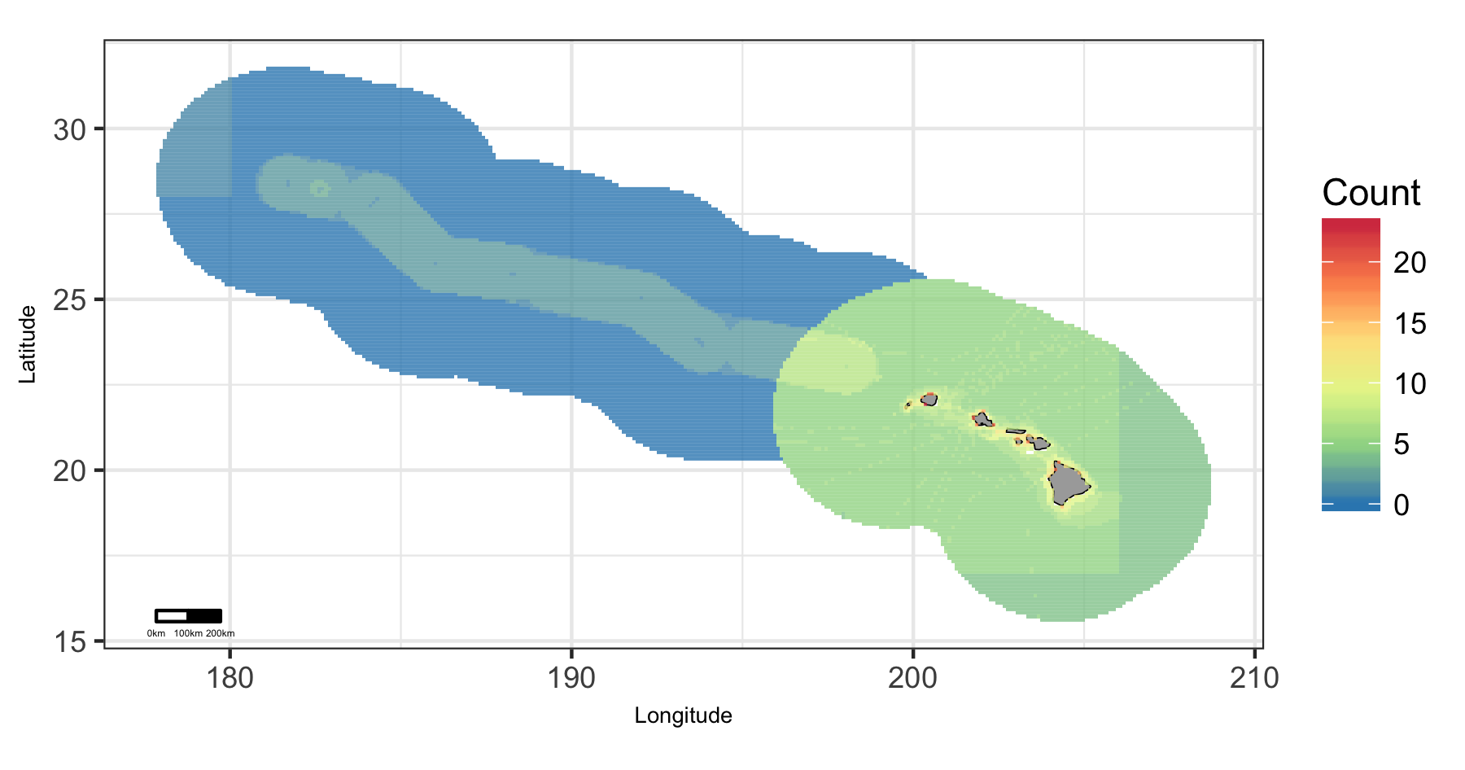

Map of cumulative ocean use in Hawaii region.

### Hawaii: Map of Depth

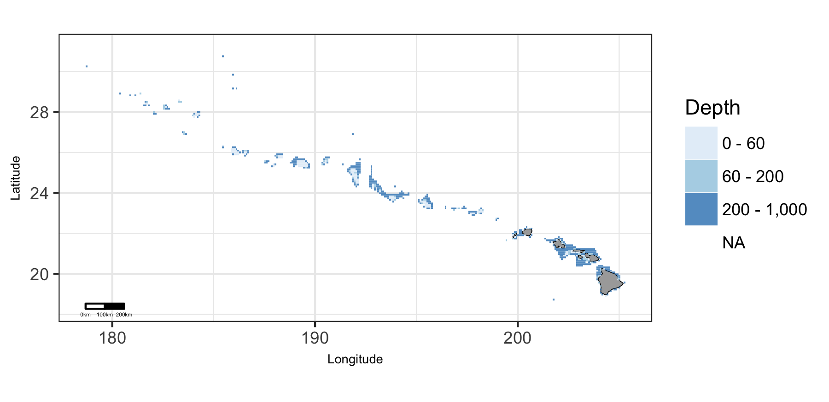

Map of viable depth in Hawaii region.

### Hawaii: Plot of Uses by Depth

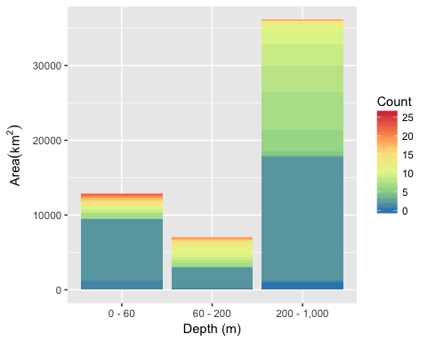

Area of Cumulative Ocean Use by Depth (m) for Hawaii region. Cumulative use are counted and summarized by Depth (m) and area.

### Hawaii: Table of Uses by Depth

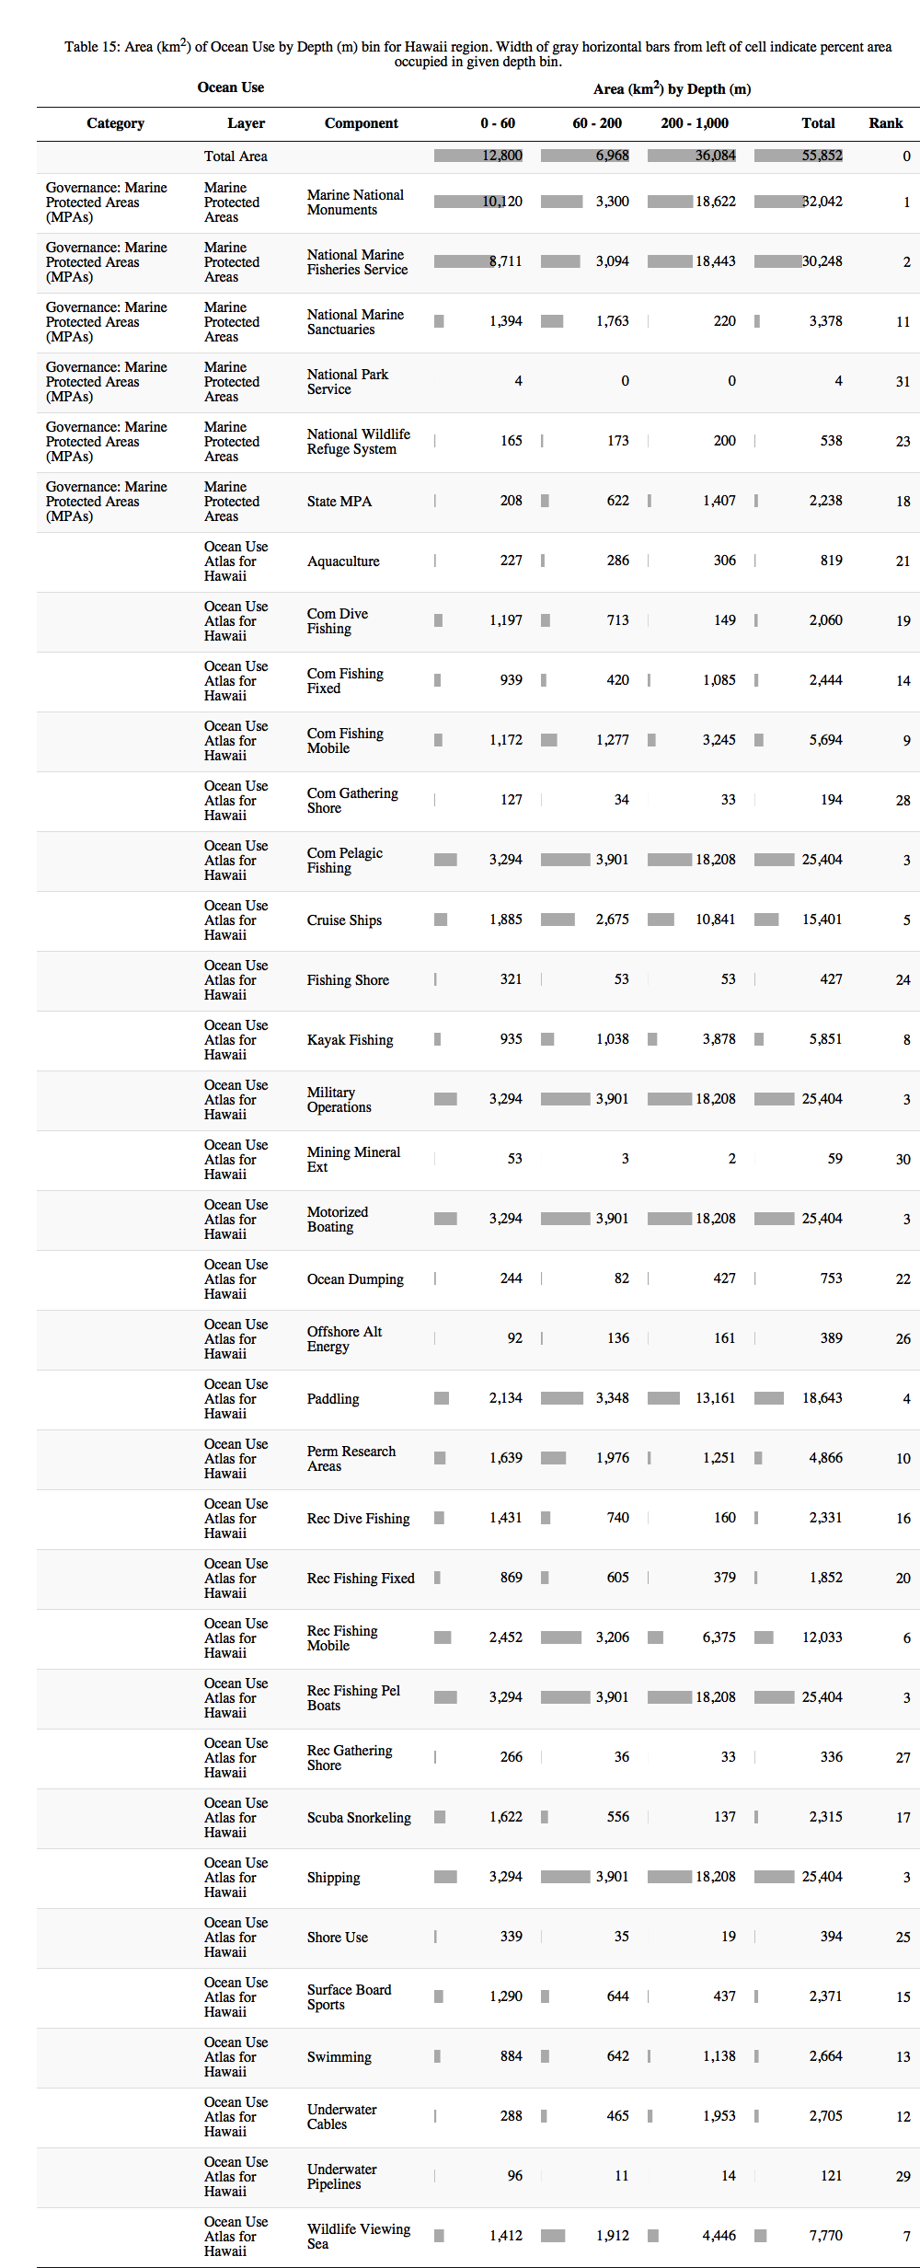

### Hawaii: Map of Wave

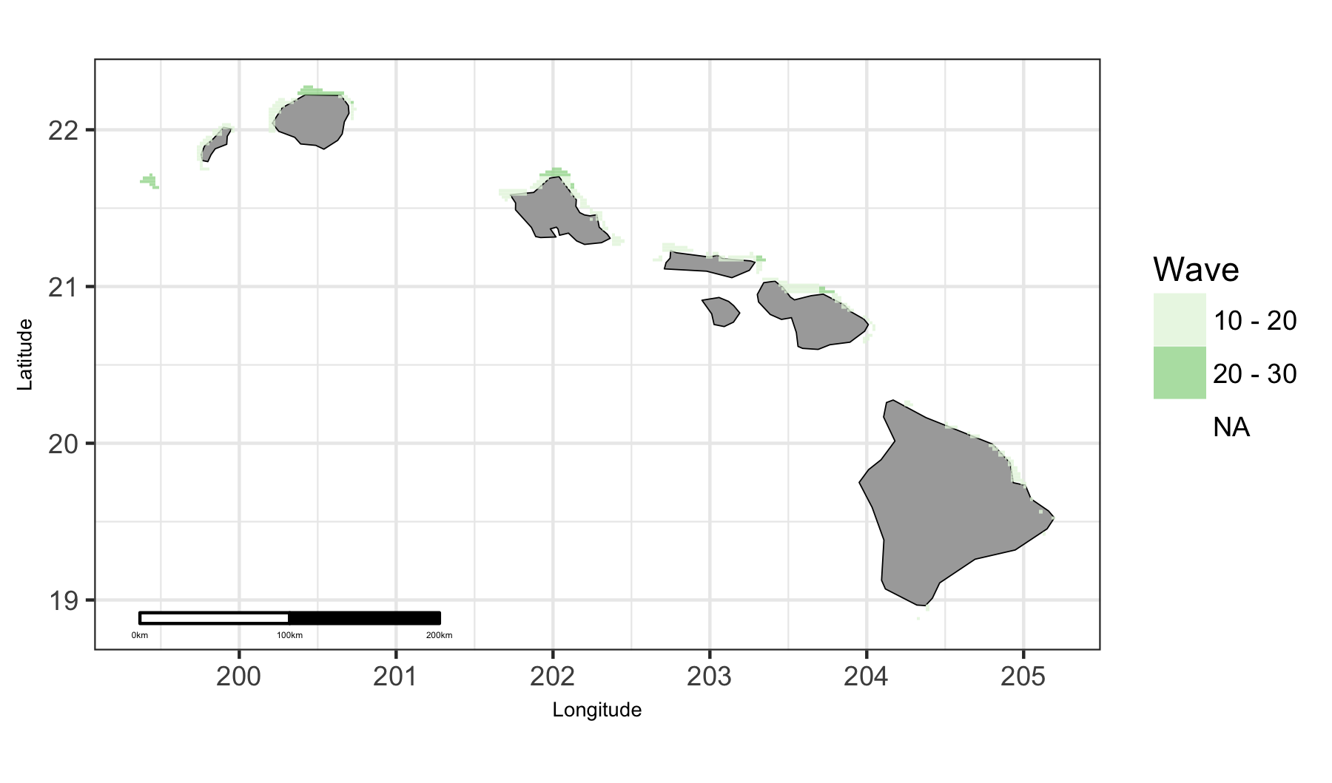

Map of viable wave in Hawaii region.

### Hawaii: Plot of Uses by Wave

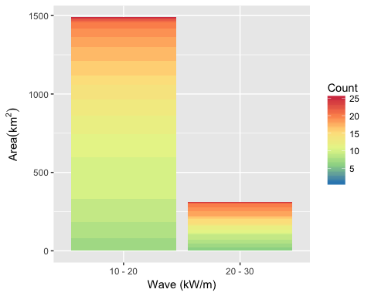

Area of Cumulative Ocean Use by Wave (kW/m) for Hawaii region. Cumulative use are counted and summarized by Wave (kW/m) and area.

### Hawaii: Table of Uses by Wave

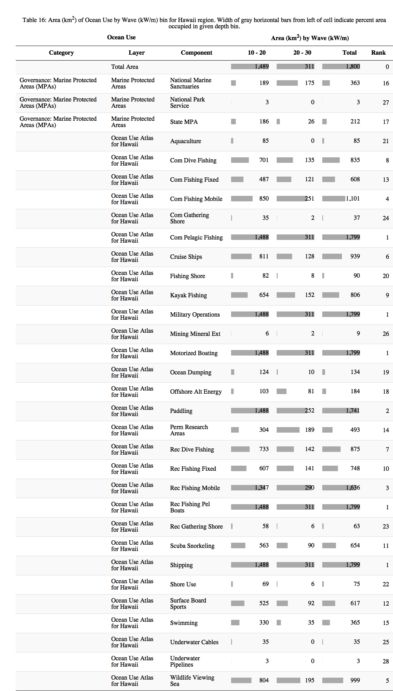

### Hawaii: Map of Wind

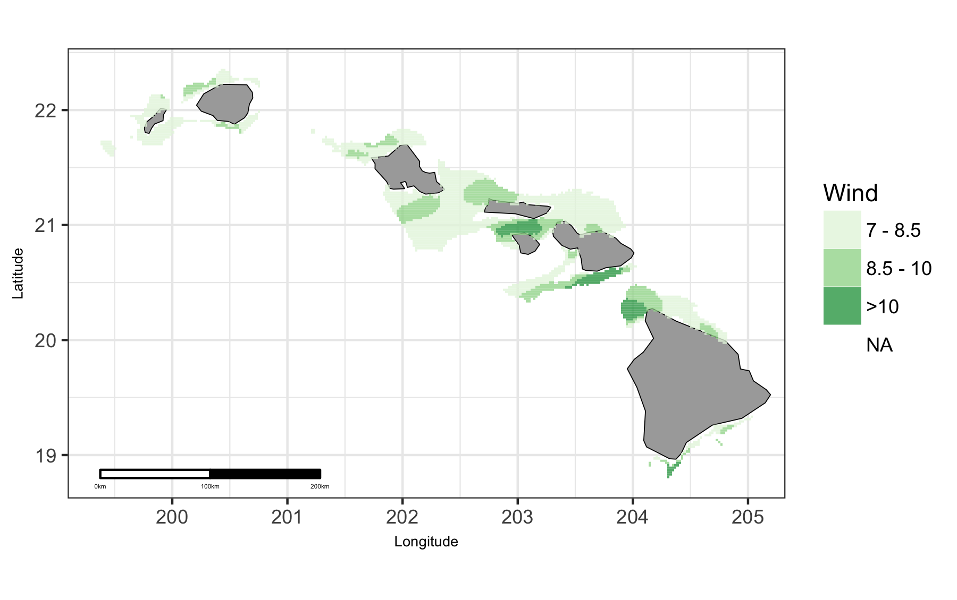

Map of viable wind in Hawaii region.

### Hawaii: Plot of Uses by Wind

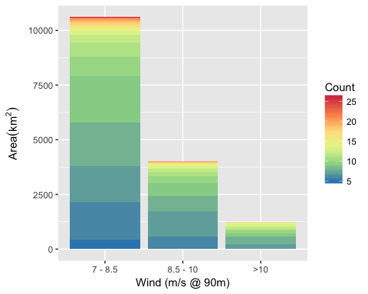

Area of Cumulative Ocean Use by Wind (m/s @ 90m) for Hawaii region. Cumulative use are counted and summarized by Wind (m/s @ 90m) and area.

### Hawaii: Table of Uses by Wind

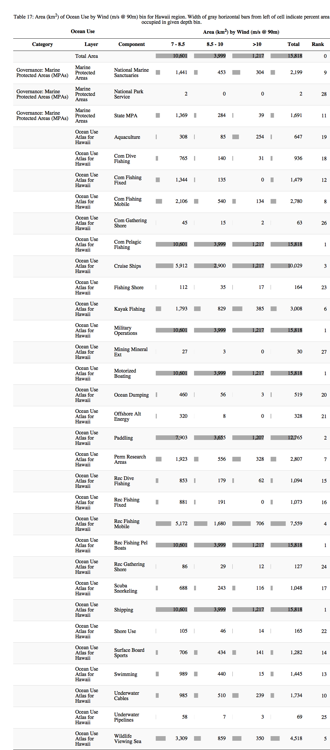

## Pacific Islands

### Pacific Islands: Map of Uses

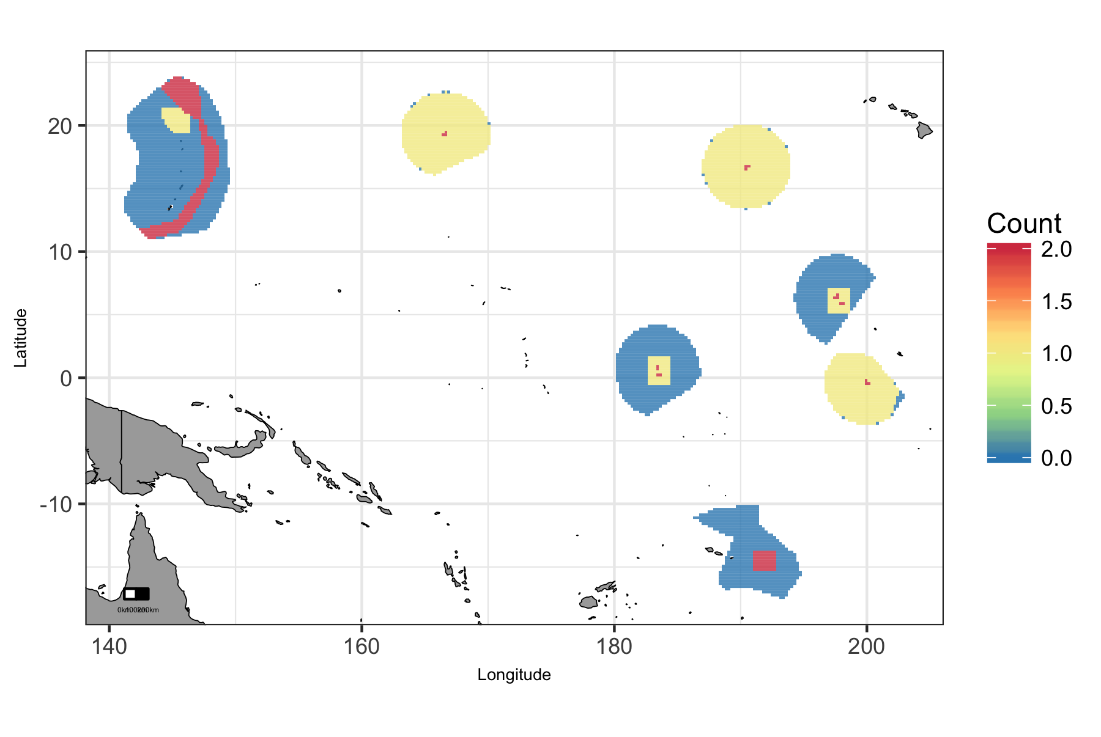

Map of cumulative ocean use in Pacific Islands region.

### Pacific Islands: Map of Depth

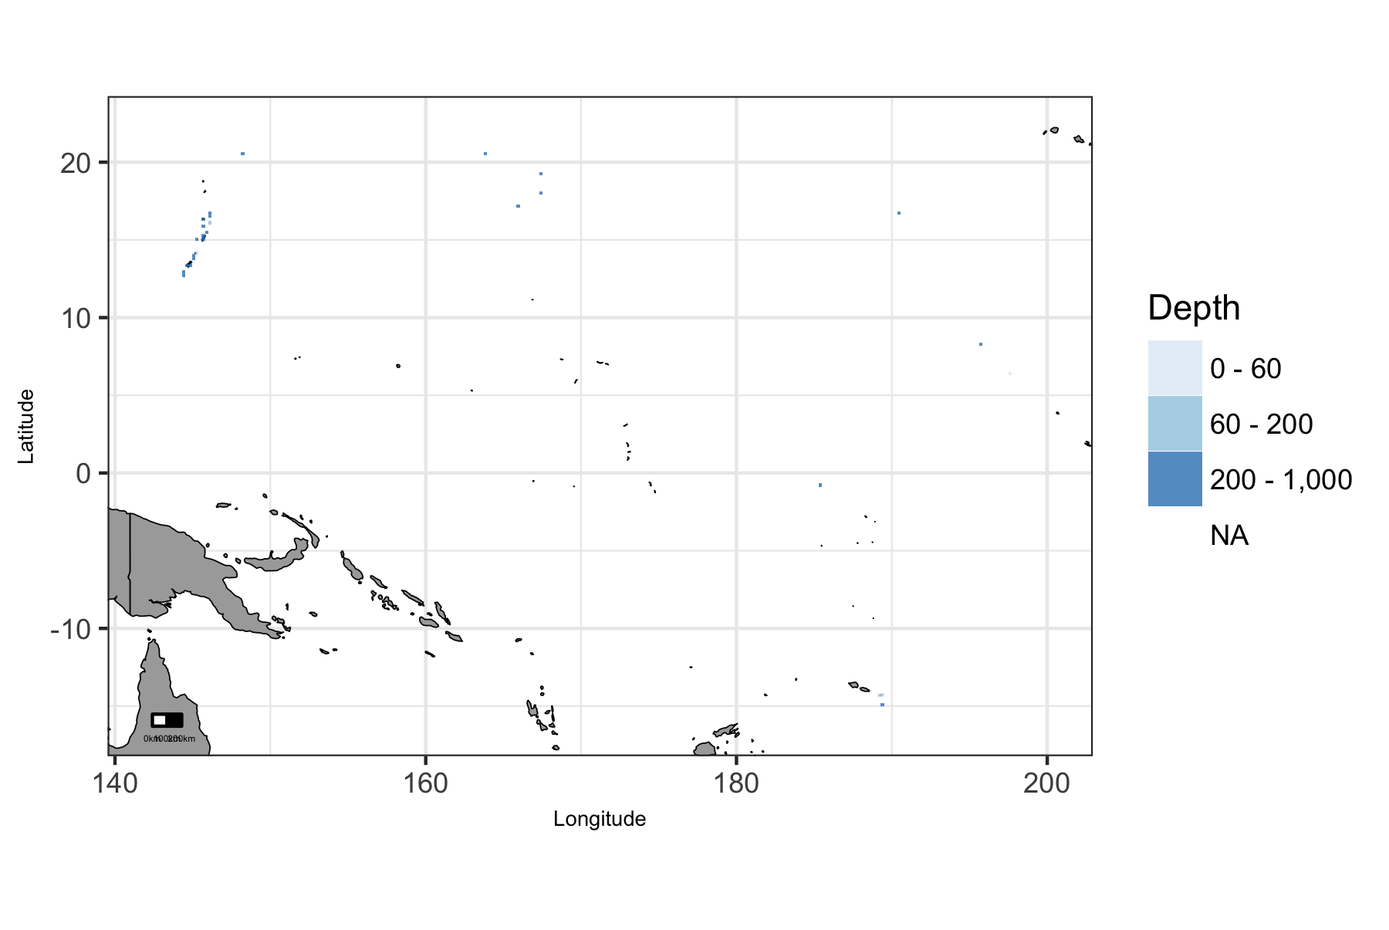

Map of viable depth in Pacific Islands region.

### Pacific Islands: Plot of Uses by Depth

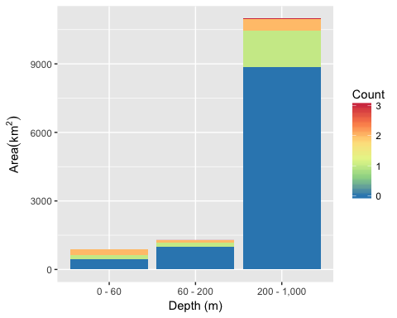

Area of Cumulative Ocean Use by Depth (m) for Pacific Islands region. Cumulative use are counted and summarized by Depth (m) and area.

### Pacific Islands: Table of Uses by Depth

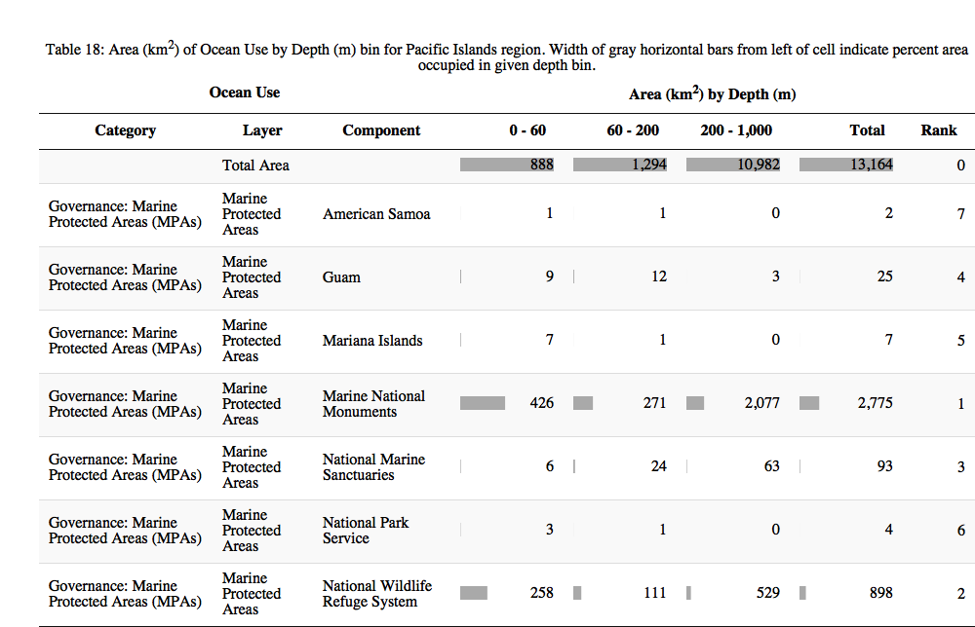

## West

### West: Map of Uses

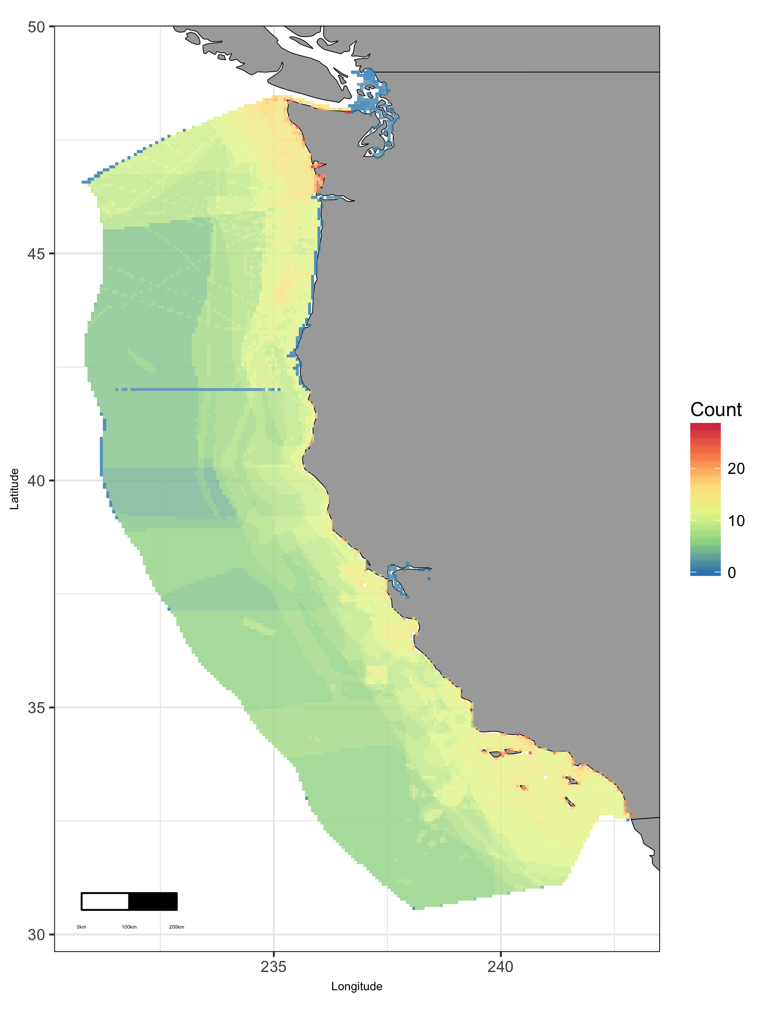

Map of cumulative ocean use in West region.

### West: Map of Depth

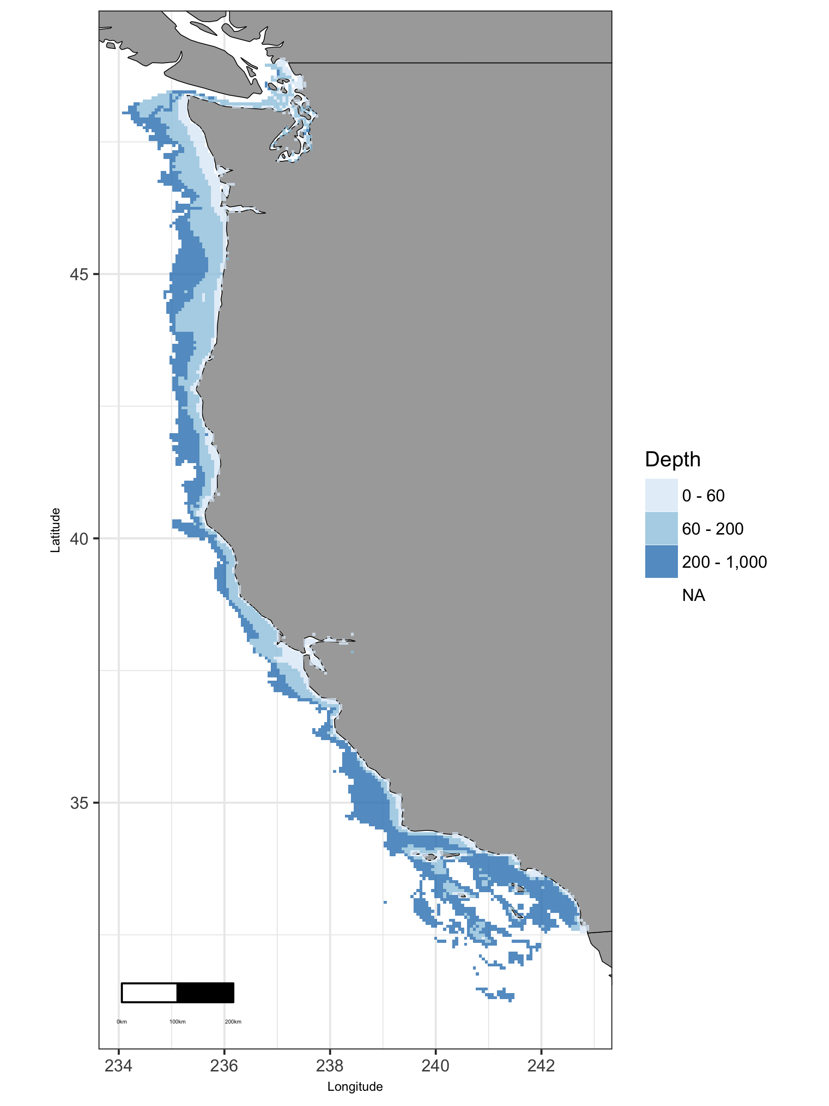

Map of viable depth in West region.

### West: Plot of Uses by Depth

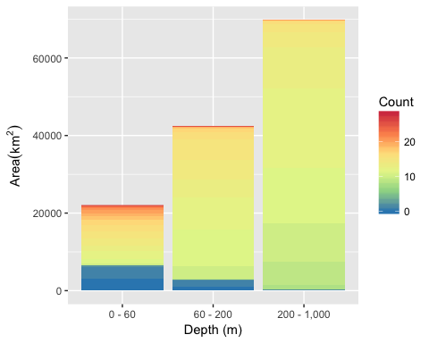

Area of Cumulative Ocean Use by Depth (m) for West region. Cumulative use are counted and summarized by Depth (m) and area.

### West: Table of Uses by Depth

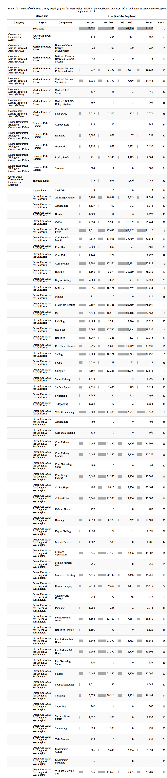

### West: Map of Tide

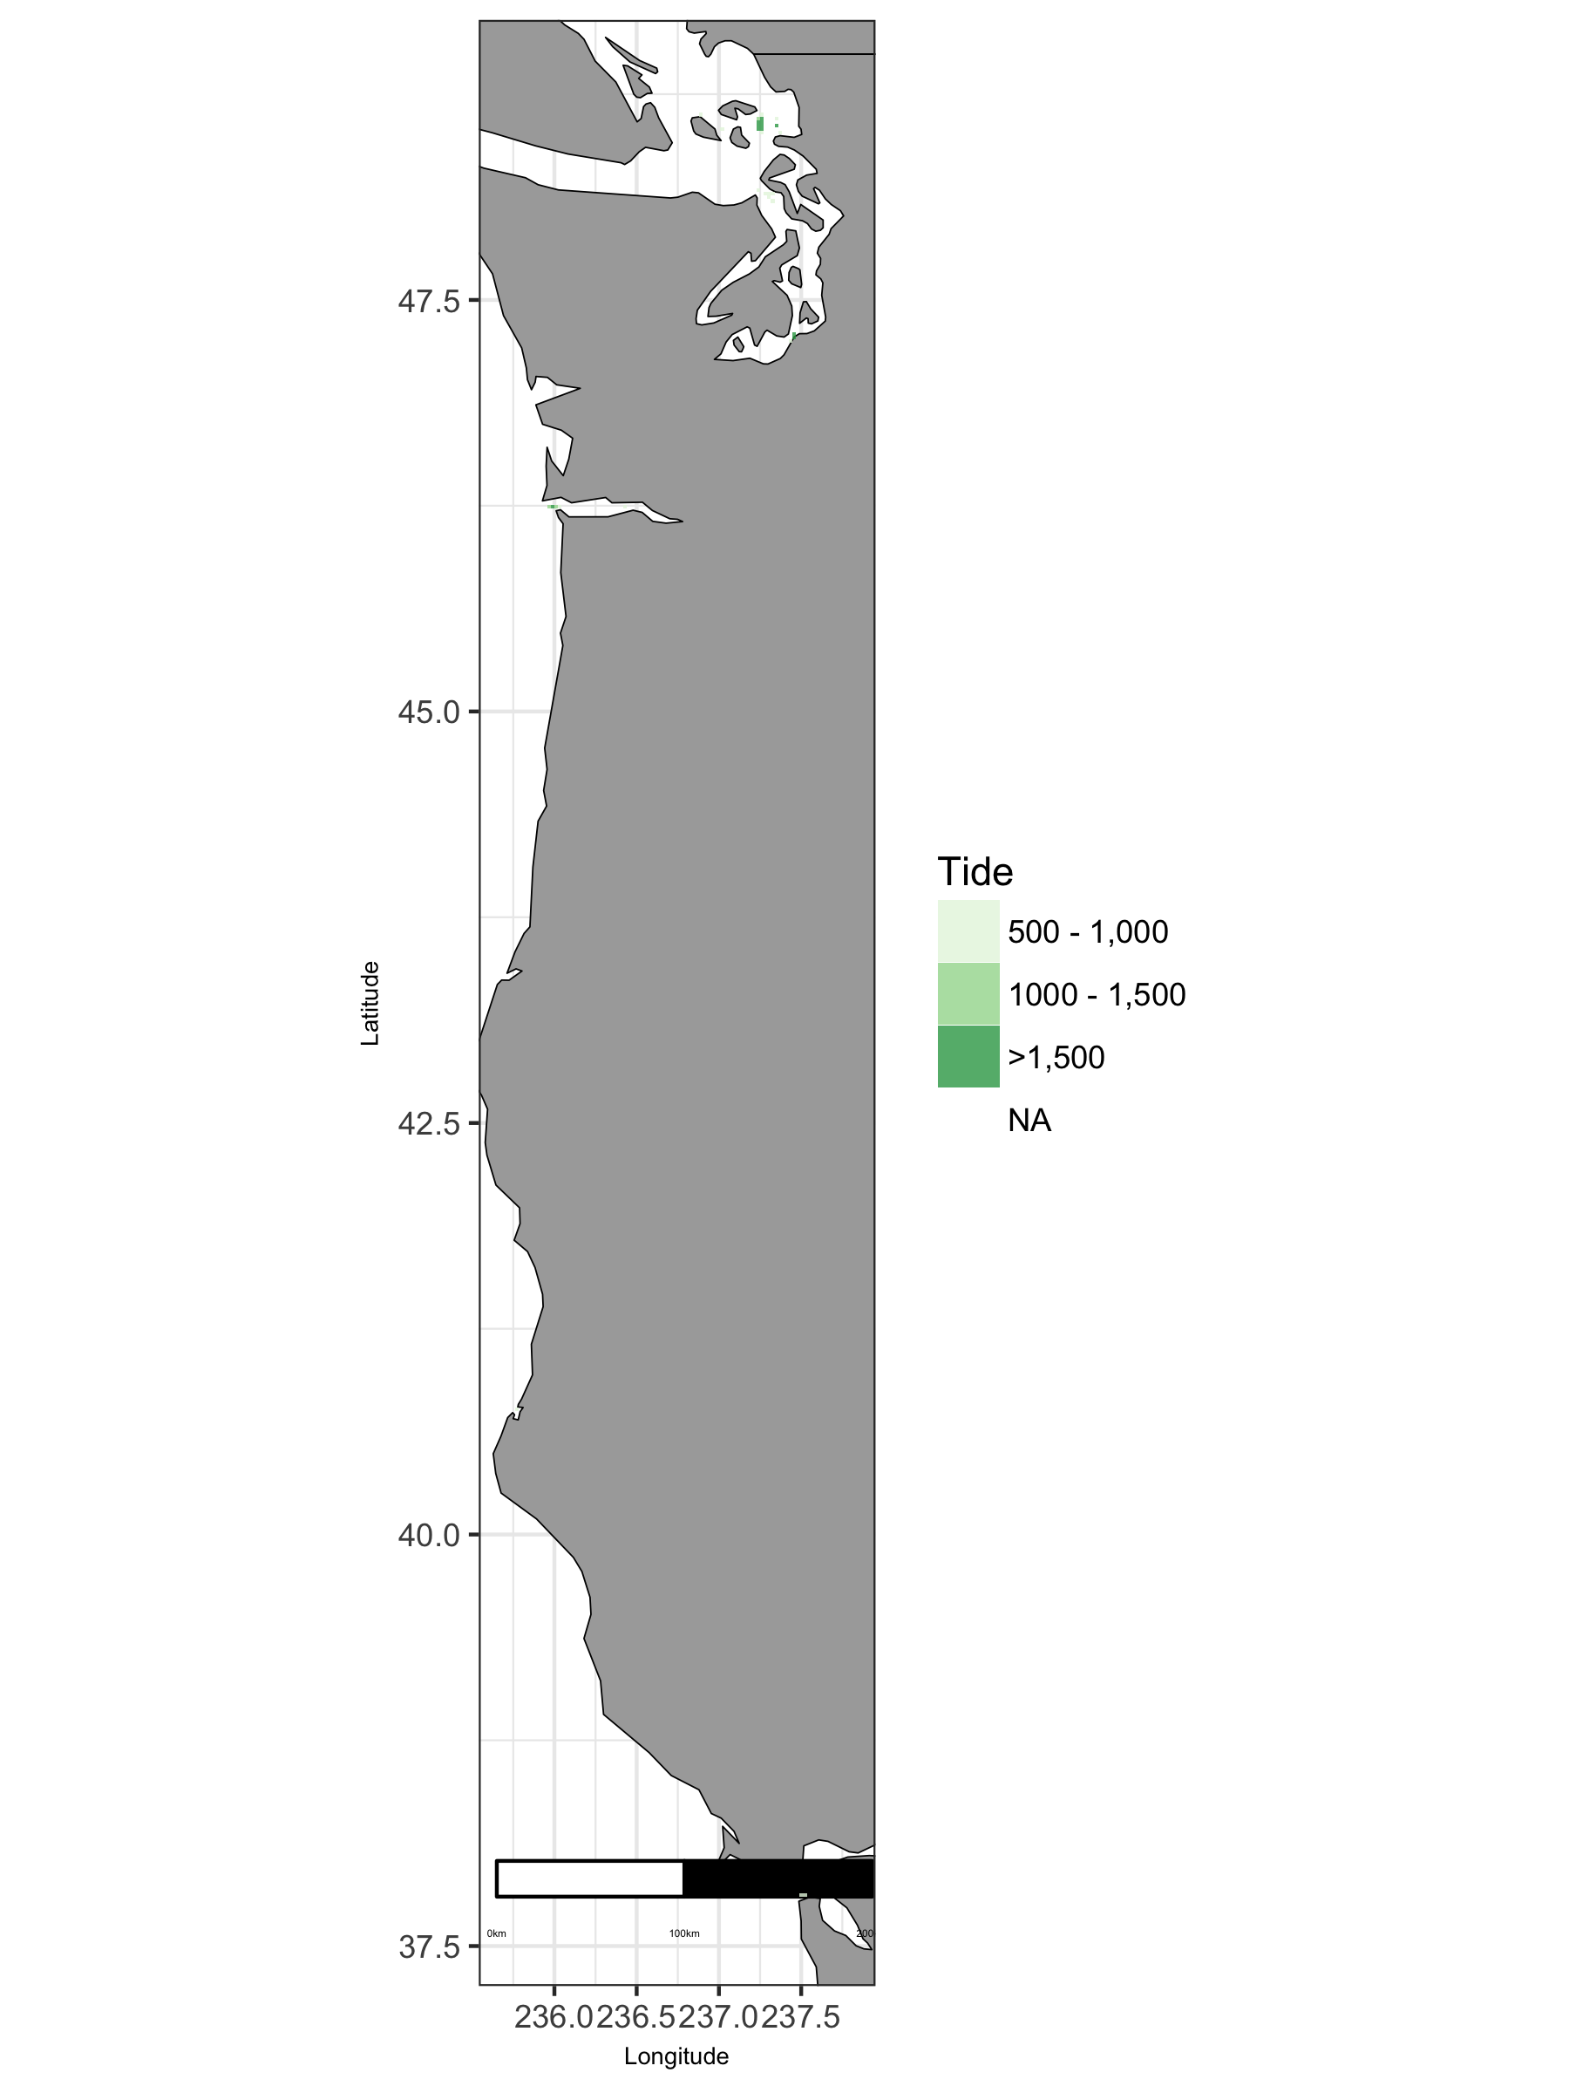

Map of viable tide in West region.

### West: Plot of Uses by Tide

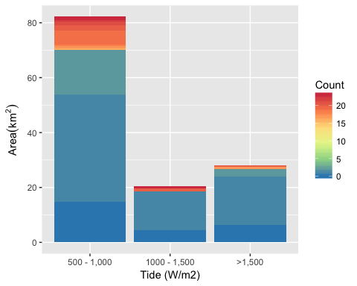

Area of Cumulative Ocean Use by Tide (W/m2) for West region. Cumulative use are counted and summarized by Tide (W/m2) and area.

### West: Table of Uses by Tide

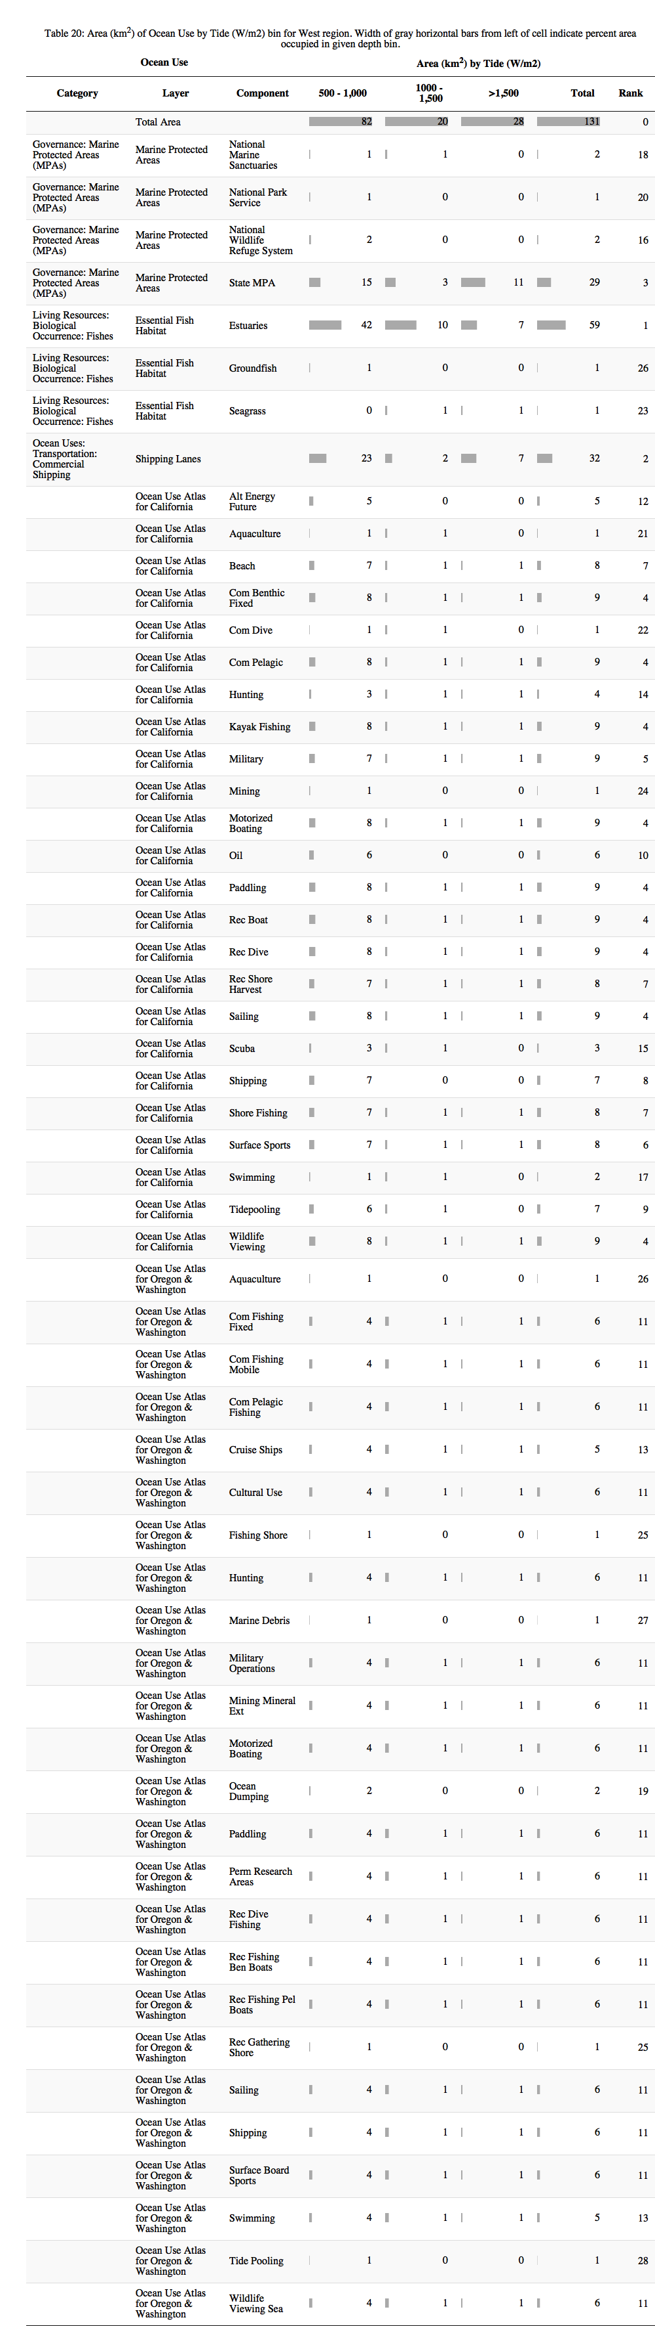

### West: Map of Wave

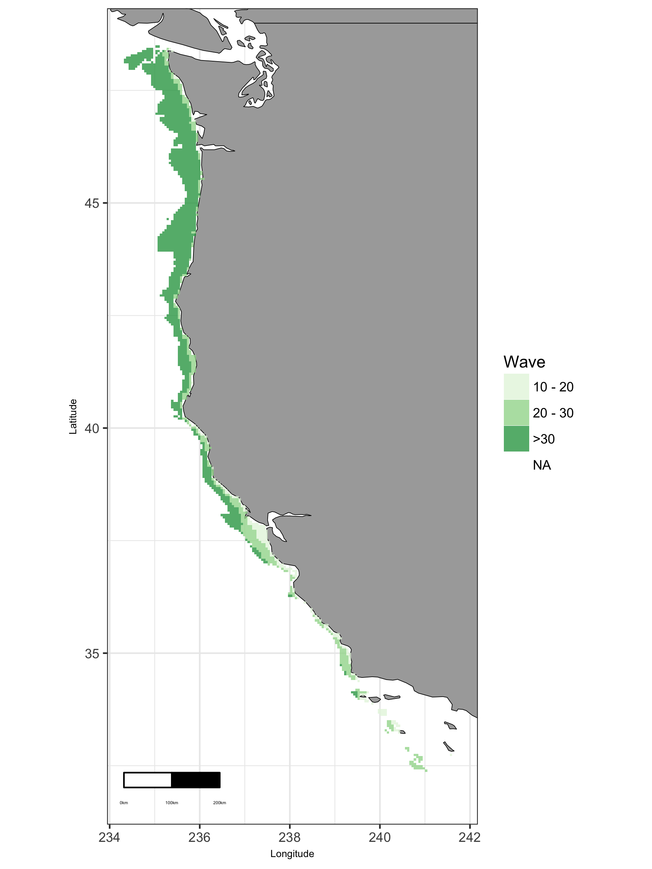

Map of viable wave in West region.

### West: Plot of Uses by Wave

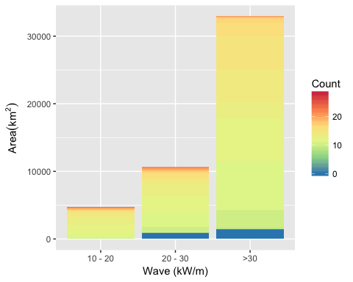

Area of Cumulative Ocean Use by Wave (kW/m) for West region. Cumulative use are counted and summarized by Wave (kW/m) and area.

### West: Table of Uses by Wave

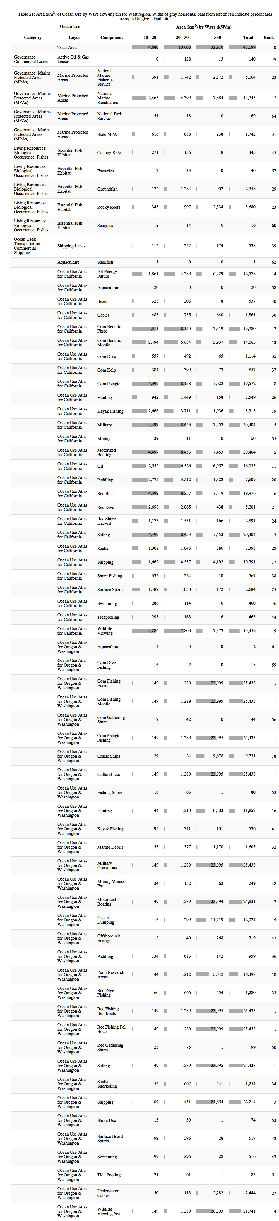

### West: Map of Wind

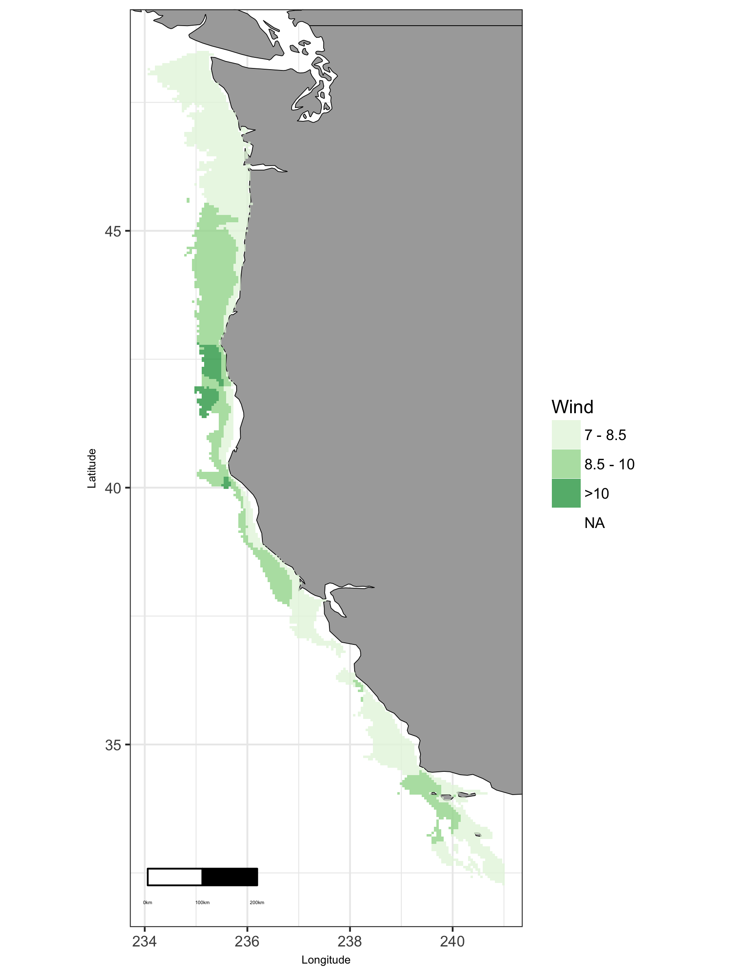

Map of viable wind in West region.

### West: Plot of Uses by Wind

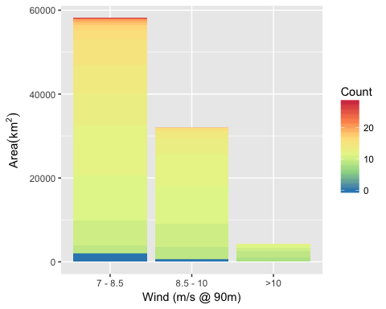

Area of Cumulative Ocean Use by Wind (m/s @ 90m) for West region. Cumulative use are counted and summarized by Wind (m/s @ 90m) and area.

### West: Table of Uses by Wind

